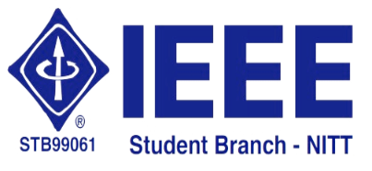 | National Institute of Technology,  Tiruchirappalli – 620 015 | 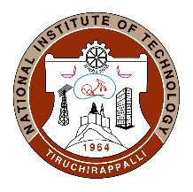

29.05.2020
IEEE Student Branch Activity Report for May 2020 – Technical Talk by Dr. B Dastagiri Reddy on 29.05.2020

The IEEE Student Branch of NIT-Tiruchirappalli organized a technical talk via WebEx Meetings on “Flash Charging Technology for New Generation e-Bus” by Dr. B Dastagiri Reddy, Assistant Professor, Department of Electrical and Electronics Engineering, National Institute of Technology Surathkal, Karnataka. Registration form was created for the event, using which participants registered their basic details. Meeting link was shared with the registered participants.
Dr. Reddy was one of the members of the ABB team that developed the Flash charging technology, an in-route charging solution for new generation electric buses. He started the talk by comparing the flash charging technology with conventional charging solutions like depot charging and terminal charging and emphasized its advantages like reduced battery deadweight, longer battery life and quicker charging. He then explained the drivetrain solutions along with the charger topologies. The software aspects of this technology like design optimization, traffic simulation and asset management were covered next. He concluded the talk after giving the implementation details of this technology in Geneva, Nantes and Brisbane. This technical talk was attended by UG, PG students and Ph.D. Scholars from CSE, EEE and ECE departments.
Technical talk's video can be found in the link:
https://nitt.webex.com/recordingservice/sites/nitt/recording/playback/9ae9e39b252849a6a1523cf1ba331279

