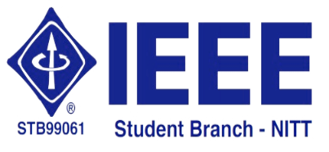 | National Institute of Technology,  Tiruchirappalli – 620 015 | 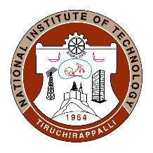

16.01.2020
IEEE Student Branch Activity Report for May 2020 –
Technical Talk by Dr. Damodar Reddy Edla on 15.05.2020

The IEEE Student Branch of NIT-Tiruchirappalli organized a technical talk via WebEx Meetings on “Advances in Brain Computer Interface” by Dr. Damodar Reddy Edla, Assistant Professor, Department of Computer Science and Engineering, National Institute of Technology, Goa. Registration form was created for the event, using which participants registered their basic details. Meeting link was shared with the registered participant.
Dr. Reddy gave brief introduction about the domain of Brain Computer Interface. Different parts of brain and the responsibility of each part in human activity has been discussed. Dr. Reddy gave several real time examples for understanding the applications of BCI. The research works going on in the field of BCI and their effect in the modern society have been discussed. Dr. Reddy explained about the advances in the field of BCI and the expected applications which will be designed with BCI in future are discussed. The technical talk was attended by UG, PG and Ph.D. Scholars and faculties from CSE, EEE and ECE departments. Participants are motivated by Dr. Reddy to do the research in the field of BCI as it is one of the emerging and effective field which will be useful for the modern society.
Technical Talk's video can be found in the link:
https://nitt.webex.com/recordingservice/sites/nitt/recording/playback/6337dc3a017d4e3d93680b23e5d7d757

