|  |  |  |
| --- | --- | --- |
| **(STB99061)** | **https://www.nitt.edu/home/about/Low-Resolution-Emblem.pngNational Institute of Technology,**  **Tiruchirappalli – 620 015** | **https://www.nitt.edu/home/about/Low-Resolution-Emblem.png** |

**04.03.2020**

**IEEE Student Branch Activity Report for February 2020–Awareness Program on Power and Energy for School Students**

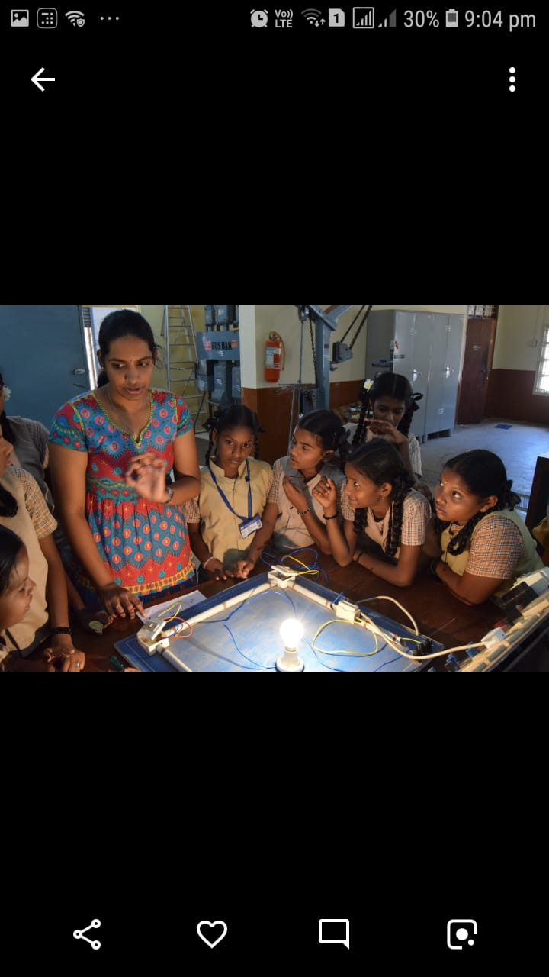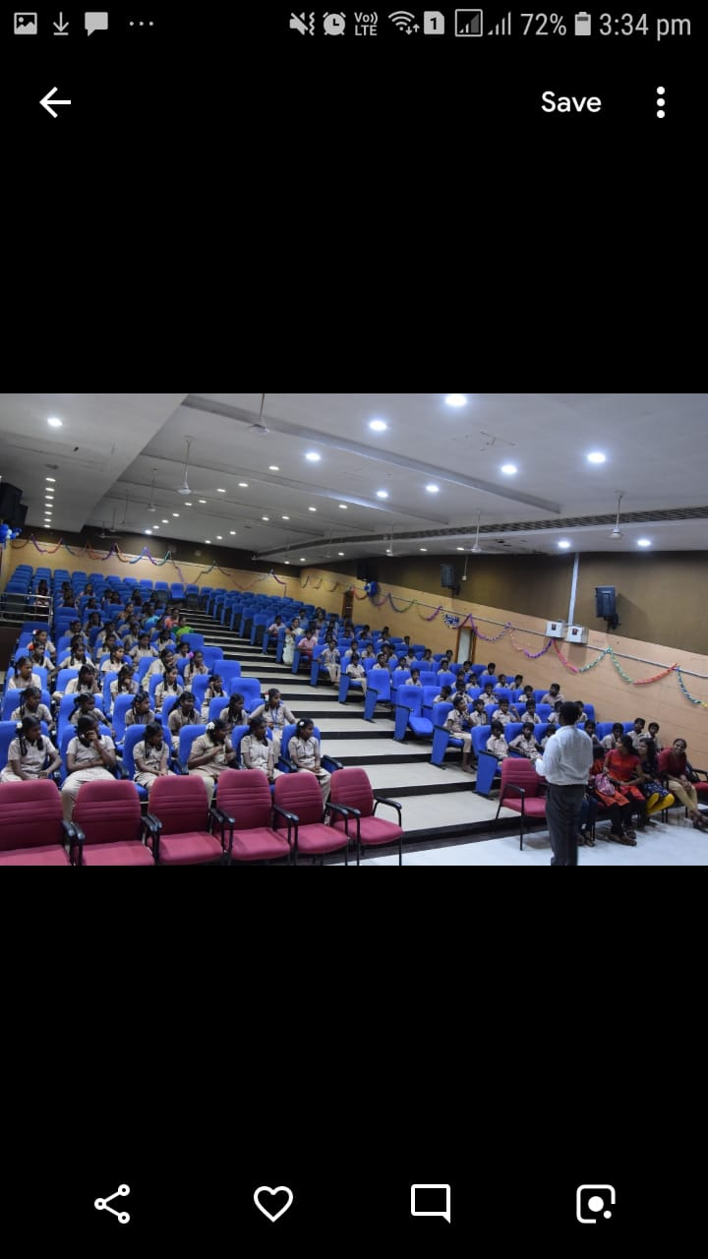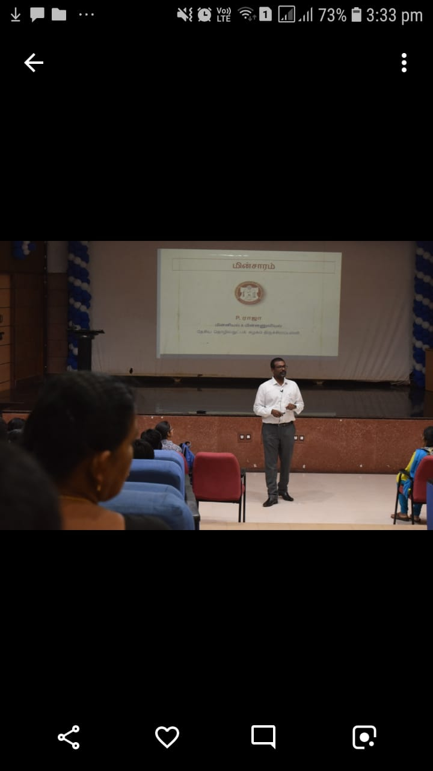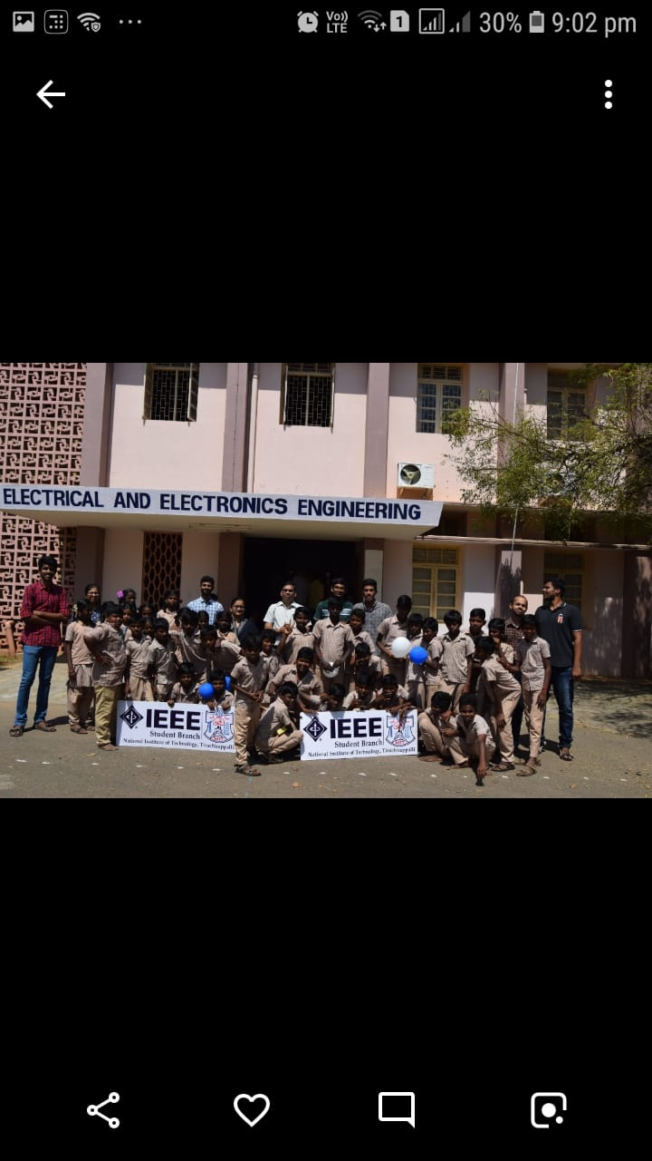 The EEE association on NIT Tiruchirappalli in association with the IEEE Student Branch conducted an event on 04.02.2020 for the students of REC Middle School, Thuvakudi for creating awareness on Power and Energy as a part of technical symposium “CURRENTS 20”. Dr. P. Raja, Associate Professor/EEE, NITT addressed the students at the EEE Auditorium, NIT Trichy. In an half a day session, school students were trained by volunteers from EEE association and IEEE SB. They were given presentation on working principles of several electrical appliances used in day to day life. The house wiring from service mains to the load was shown to them through demonstration kits made by the EEE students of NITT. The working principle of transformer was explained to them through experimentation. The importance of wind energy and solar energy was described to the participants. Demonstration was also given on principle and technology of e-bike.