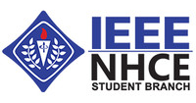

NHCE IEEE STUDENT BRANCH ANNUAL GENERAL MEET 2021

The IEEE student branch organised their annual general meet on 4th February 2021 at new horizon college of engineering, Bangalore.

Minutes of the meeting:
- The IEEE student branch general meeting started at 10 am on 4th Feb.
- Dr Nisha, branch counsellor initiated the proceedings of the meeting by welcoming the IEEE members, dignitaries, and staffs.
- Dr Sanjeev Sharma, HOD of ECE dept. and Dr M Mahesh, HOD of EEE Dept. were invited as the dignitaries for the annual general meeting.
- Dr Nisha, gave in a brief description of the contribution of IEEE SB in the year 2020, and summed up the kind of activities that were organised in the previous year.
- Followed by that, the financial report of the year 2020 was proposed by her.
- The office bearers for the year 2021 was announced by the dignitaries and the branch counsellor.
- Devika Krishnan from 3rd year ECE, was appointed as the IEEE student chair, Srinidhi S from 3rd year ME, was appointed as the IEEE student vice chair, Vignesh A M from 3rd year ME, was appointed as the treasurer and Divya Shree R from 3rd year ECE, was appointed as the IEEE student Secretary.
- The office bearers were proposed by Mrs Nisha, and it was seconded by Dr Sanjeev Sharma, HOD ECE
- Webmaster and 6 Exe-com members were proposed by Mrs Nisha and it was seconded by Dr M Mahesh, HOD EEE.
- IEEE student chair, Devika Krishnan proposed the annual plan for the year 2021, which included the kind of activities that would be conducted and the membership drive target for 2021.
- The meeting was concluded, by Srinidhi S, IEEE student vice chair.

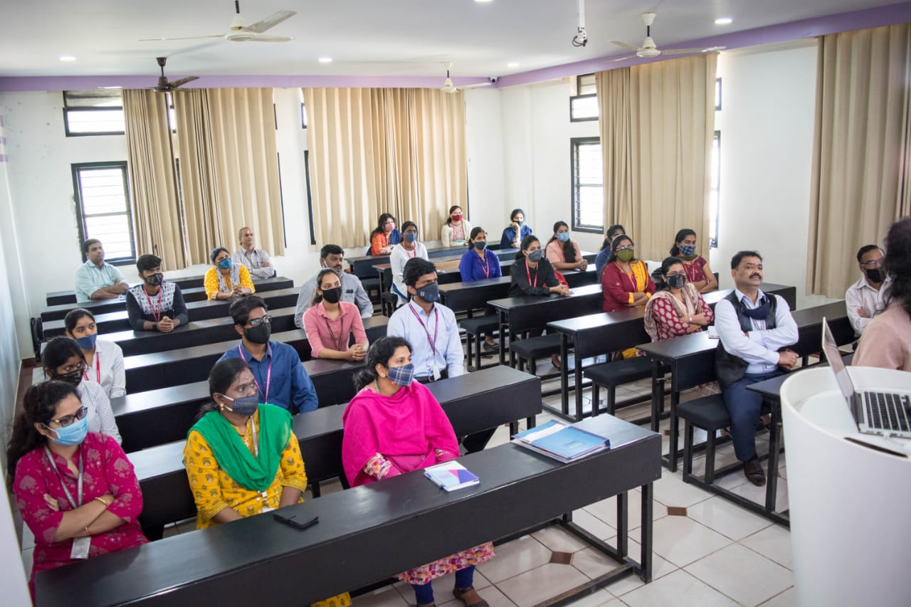
ANNUAL GENERAL MEETING – 2021

