CRYPTIC: Talk is a bore, show me the CODE
Date: 18th May 2021
Time: 2:00 PM to 5:45 PM
Mode: Online (Coding event)
Total Number of Participants: 65
The event began with a welcome speech and a brief overview of the entire event.
The event started with the rules of Round 1: ERRORZONE. This was a quiz round conducted on the Quizizz Platform with questions on outputs and error-related code snippets. All the participants answered the questions and 36 of them were shortlisted based on time and accuracy.
After a break of 15 minutes, the event continued with Round 2: BREAKING PATTERN. This round was all about finding the missing part of a function in the given codes and designing the logic to print the given patterns in 25 minutes.
The questions were provided to them through a Google form. In addition, all the participants needed to turn on their videos via the Zoom platform for invigilation. After the completion of round 2, 12 participants were shortlisted for round 3 based on the accuracy of the solutions in round 2.
The 3rd round: CRACK THE GEEK, started after an hour with the final 12 participants. In this round, everyone was given one code question to unleash the coding geek within them. For invigilation purposes, the participants were divided among the IEEE NHCE Student branch members. One or two of the participants were required to join the respective zoom meeting of the IEEE team member assigned to them. After joining the respective meeting, the participants were given 30 minutes to solve the question with their screens shared and videos turned on mandatorily.
After the completion of round 3, all the answers were evaluated by the IEEE NHCE team and the top 2 winners were chosen.
The event successfully ended with the announcement of the top 2 winners on the WhatsApp group created for the participants.
In the end, the participants shared their valuable feedback and received their certificates

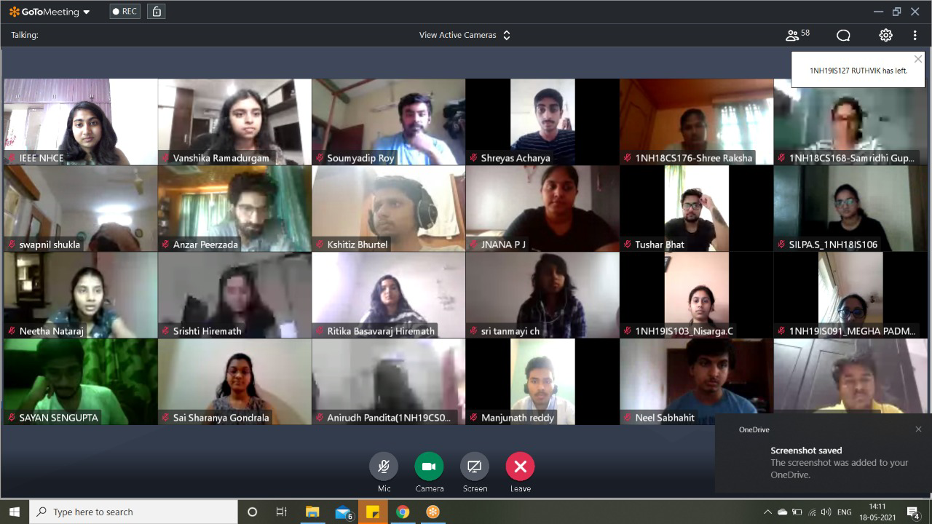
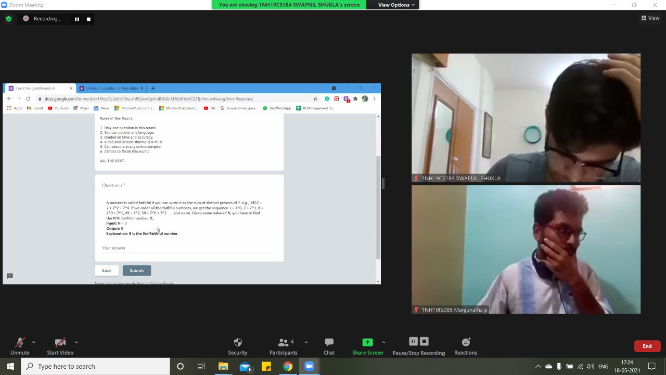
PARTICIPANTS LIST:
- 1NH19CS184_SWAPNIL
- samhita_1NH19IS088
- ANIRUDHPANDITA_1NH19CS018
- SONALI_1NH18IS109
- 1NH18CS199_VENKATA SAI KU
- KriteshPokhrel 1NH18CS207
- NeelSabhahit_1NH19CS111
- Akash B U_1NH18CS704
- 1NH19CS061 Himanshu (
- surya _1NH19EC115
- Peerzada Anzar_1NH19CS123
- Vishnu Girish G_1NH20CS41
- Neetha Nataraj_1NH18EC077
- RAHUL 1NH19IS111
- DECHAMMA V S_1NH19EE027
- VISHAL_NIKHIL_1NH18CS201
- Keerthan H_1NH18IS048
- G Sai Sharanya_1NH18IS035
- 1NH19CS074_Kasish
- KshitizBhurtel_1NH18CS208
- Shivangi 1nh19Cs164
- Geetha sree_1NH18CS162
- SILPAS_1NH18IS106
- NISARGA.C _1N19IS103
- 1NH19CS007_shusma
- Samridhi Gupta_1NH18CS168
- Aditya Kanoi 1NH19IS009
- Sumanth J_1NH18CS189
- Vijay J 1NH19CS198
- 1NH19EE038_krishna
- SHREE RAKSHA.V_1NH18CS176
- JNANA P J_1NH18IS041
- Keerthana_1NH19CS076
- Sandeep Kumar
- RUTHVIK P_1NH19IS127
- 1NH19IS085_MANJUNATHA P
- Shreyas_1NH19IS155
- Geethanjali Marpu_CS223
- 1NH18CS228_HARSHITHA
- Lakshmish_1NH19IS081
- Sai Rohith_1NH19IS090
- Sayan_1NH19IS142
- Megha Padmini_1NH19IS091
- Aishwarya Nagras _1NH18EC
- Tushar Bhat_1nh18cs196
- Prakruthi_1NH19CS132
- Hemanth Gn(1NH19EE037)
- AGARWAl rahat 1NH19EE007
- Madhura K_1NH18CS108
- surya
- SHREEYAM 1NH19CS166
- AGARWAl rahat
- Soundarya B
- 1NH19IS111_RAHUL C
- Kevin
- ANJANA_1NH19EE015
- Tushar Bhat
- Manoj Kumar
- Prakruthi
- Meela Sai Rohith_1NH19IS0
- Sumanth J
- Vijay Selvaraj J
- SHREEYAM_1NH19CS166
- 1NH19IS111_RAHUL
- 1NH18EC077_Neetha Nataraj

