Sponsorship Agreement
ELECTRICAL SAFETY WORKSHOP COSTA RICA, ESW 2019 CR
Sponsorship Agreement is a binding Contract between the parties for the execution of 2019 IEEE Electrical Safety Workshop Costa Rica, ESW 2019, (hereinafter, the "Agreement") between ______________________, (hereinafter, the "Sponsor") with identity card of legal entity _________________________ with address in _________________________, represented by ______________________, with identity card (id #) ____________________, neighbor of _______________________________, legal status that appears in the Registry of Legal Persons, volume _____, entry ______, and the Association of Engineers in Electricity and Electronics, AIEEE, (hereinafter, the "Association"), legal entity number 3-002-084618, domiciled in San José, re-presented by its President (Chair), Ing Jeffrey Peralta Umaña, mayor, married, electrical engineer, neighbor of Alajuela, identity card number 1-1066-0840, register at the Registro de Personas Jurídicas, to Volume 358, seat 9376, sequence 001.
1. INTEREST AND LEGAL CAPACITY FOR AWARDING SPONSORSHIP: The Sponsor has the interest and the legal capacity to give the Association an economic content to develop the activities associated with the 2019 Electrical Safety Workshop Costa Rica (hereinafter referred to as "the Event ") to be held at Hotel Wyndham Herradura, located in San Antonio de Belén, Heredia, Costa Rica, from May 23 to 25, 2019. The aforementioned EVENT (OBJECTIVE: The purpose of the ESW, is to spread the change electrical safety culture in practice and the design of electrical engineering and telecommunications works), as well as a field of exhibition of products and technical developments. Likewise, the promotion of the profession of agricultural engineering through ties of friendship and technical forums for the discussion of the topics that interest each country of the area in its development.
The Event is held together with the technical and professional part, (Inauguration, Inauguration of Trade Show, Cycle of Conferences, Cultural Event, Act of Closure, and Technical Tours).
2. DESCRIPTION OF THE ACTIVITY: That is sponsored. Sponsor promotes the realization of the event in clause 1.
3. ECONOMIC CONTRIBUTION AND CONDITIONS: The Sponsor will be assigned the category of Fair Sponsor, when granting the economic contribution that will be deposited in one of the bank accounts of the Association of Engineers in Electricity and Electronics, AIEEE, which will be They are detailed below, recording the legend in the deposit (NAME OF THE CONGRESS: ESW 2019 CR), in account in US dollars Banco de Costa Rica, account number # 001-119432-1 or SINPE 15201001011943210 or if it was an international transfer SWIFT BCRICRSJ . Once the deposit is made in the bank accounts of the Association, you must send a copy of the receipt to the e-mail address acc.costarica@ieee.org or fax (506) 2290-6951.
4. OBLIGATIONS OF THE ASSOCIATION: The Association undertakes to put its best effort and diligence to organize, manage, promote, publicize and execute the event and will grant the following benefits to the Sponsor according to its category, as detailed below:
TRADE SHOW SPONSOR BENEFITS
The benefits for your represented by a fair stand sponsorship will be the following:
1. Stand ______ (See Stand Distribution)
2. Two registrations for participation in the conferences of the Event.
3. Lunches for two people for the attention of exhibition space (s) on the days (May 23 and 24, 2018).
4. Refreshments for two people at the exhibition space (s) on the days (May 23 and 24, 2018).
5. Promotion on the CONGRESS website and social networks (1 video of the EVENT invitation up to 2 min maximum + 1 COMMERCIAL video of your re-presented up to 4 min).
6. You agree to place your official logo, promotional material in the folder that will be assigned to you in Google Drive of the Event.
BUSSINESS CENTER
The sponsor that acquires or not a stand, may pay a room, size to come according to the possibilities of the CONGRESS, for the personal attention of his clientele and guests or business conference, the days (TO DEFINE), Subject to a schedule to be agreed. The cost of said room will be defined once it has been selected by the SPONSOR, with the number of people and services required.
Booth Floor Plan at the Trade Show
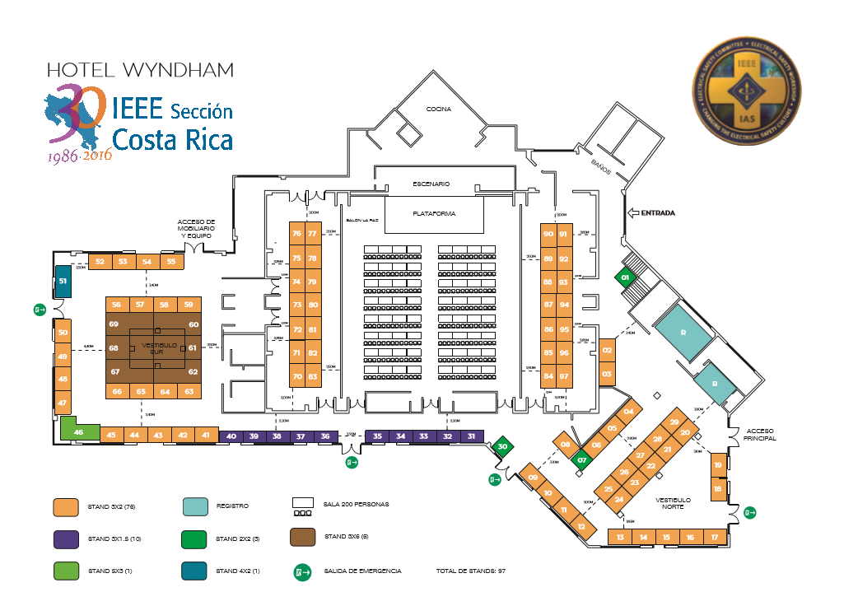
Furniture selection:
Rectangular table of 1.80m x 0.90m with tablecloth and 2 chairs with blanket
This is the basic furniture in the spaces indicated in the previous graphic.
5. CALENDARIZATION OF THE ACQUISITION OF THE SPACES IN THE TRADE SHOW
The reservation of the spaces in the Trade Show will be subject to the formalization of the Sponsorship Agreement and full compliance with the terms thus established. These spaces are the area marked on the floor if you want to customize your presentation or the infrastructure of white panels like the ones shown in clause 4 with a table and two chairs
Payments must be made in the following way:
$ 500 (five hundred US dollars) at the time of signing this agreement to reserve the space, without right to return.
[Clarification: The non-payment of this reservation amount on the agreed date, does not commit the ASSOCIATION for the promotion of the brand nor guarantees the SPONSOR the space and automatically frees the space for its sale promotion].
Balance of the exhibition space cost must be canceled according to the following payment schedule.
o Space Reserve of US$500 ____ / _____ / ____
o First payment of the balance: ____ / _____ / ____
o Second Balance Credit: ____ / _____ / ____
o Third Balance Credit: ____ / _____ / ____
o Final payment: ____ / _____ / ____
The Sponsor may choose one of the categories indicated below according to the attached Sponsorship Programs document:
or DIAMOND ( )
or PLATINUM ( )
or GOLD ( )
or SILVER ( )
or BRONZE ( )
Failure to comply with the dates agreed upon immediately will activate the clause 7. Conditional Termination of the Agreement.
6. OBLIGATIONS OF THE SPONSOR: In consideration of the benefits granted by the Association, according to each category of sponsorship, the Sponsor commits to the following: A) Make payments of his participation in the CONGRESS, in one of the accounts or set of bank accounts in the amount of US $ ____________ of the Association and inform it as detailed in clause 3 of this agreement. B) Cooperate with the Association in the realization of the purposes of this Agreement. C) Authorize the Association to use its logos and business name in the promotion of the CONGRESS, both in print and electronically, as well as in the electronic portals of the Association. D) The SPONSOR must indicate the people of his company who would be responsible for the delivery of information and coordinate payments as appropriate:

Name | Department | Phone | Email
In the event that the sending of information and payments is not coordinated, the ASOCIATION may activate Clause 7. E) The SPONSOR shall provide:
- the official logo of your company or represented,
- 1 or 2 videos between 30 seconds to 2 minutes promoting the participation to the CONGRESS, the ASSOCIATION will have the freedom to use them to use them in their websites as well as social networks.
7. CONDITIONAL TERMINATION OF THE AGREEMENT: At the request of the Sponsor and for justified reasons of fortuitous event or force majeure, the Association may accept the early termination of this agreement. If the Association accepts the early termination of this agreement, the Sponsor must sign a settlement and reimburse the Association for all direct expenses incurred in the promotion of the activity, on the date of termination and in addition an indemnity of thirty. and three percent (33%) of the sponsorship offered, an amount that considers the promotion of the brand and other advertising that has been made since the signing of the contract. The Association will terminate this agreement, unilaterally, if the Sponsor does not pay the total financial contribution to which it was committed, according to the category, at least three (3) months before the date of the event, with which the Sponsor will not receive any of the benefits offered during the celebration of the event remaining committed to the amounts specified in the payment schedule to that date and the Association will keep any advance received, in order to compensate for the lack of compliance and will have the space at its discretion.
8. RESOLUTION OF DISPUTES: This agreement will be interpreted in accordance with the laws of the Republic of Costa Rica. All disputes, claims and other issues that arise between the parties, due to this Agreement or related to it or the breach of the terms thereof, will be resolved in the first instance, through Mediation or Resolution. Alternative of Conflicts or of any other type of mediator, agreed by the parties. If any dispute arises under this Agreement, the parties shall have the right to recover the reasonable attorneys' fees and costs, unless the parties agree that the disputes be resolved by arbitration as follows: Arbitration: for which they sign in the spaces that follow, as a sign of express agreement, The Sponsor (____), The Association (___) agree that disputes not resolved by mediation, are resolved by neutral binding arbitration, or other type of arbitrator agreed by the parts. In case of any arbitration or litigation to enforce the arbitration clause of this Agreement or of an arbitration award, each of the parties will pay their own fees, costs and expenses, including attorneys' fees, and will also divide the fees of arbitrators and administrative arbitration fees.
9. VARIOUS: This Agreement is binding on the Association and the Sponsor, their representatives, administrators, successors and assigns. This Agreement is between the Sponsor and the Association. No prior agreement will be binding between the Sponsor and the Association, if it is not included in this Agreement. The modifications communicated by fax with the signature of both parties will be considered as originals.
Date: Signature of Sponsor: _______________________
(Name) _______________________________ Phone ________________, Fax ______________, ________________ Email Address ___________________________________________ Address: ____________________________________________________________________________________________________________________________________.

Date: ____ of _______ 2018, Signature of Organizing Committee: ______________
German Moya Rojas Telephone: (506) 8381-1030, Fax: (506) 2290-6951, Email g.moya@ieee.org, Address: Avenida 4, Calle 80, Casa # 05, San José, Costa Rica, 10108 .
Date: ____ of _________ of 2018, Association Signature: ____________________
Jeffrey Peralta Umaña, Telephone: (506) 8707-8156, Fax: (506) 2290-6951, Email jeffrey.peraltaumana.cr@ieee.org, Address: Avenida 4, Calle 80, Casa # 05, San José, Costa Rica, 10108.

Annex 1:
Data Place data in the exhibition space and in the book of the participants in the EVENT.
Description of the good or service
Legal / Physics Certificate:
* BN customer
Tradename:
Phones:
E-mail:
Website or Facebook:
Contact person at the Trade Show: (maximum 3 regions or 60 characters)

Annex 2: TYPE OF EXHIBITION SPACE.

Selection | Category | Furniture | Image
 | My own design | Types of walls and furniture is the sole responsibility of the Sponsor
 | Basic | Walls of white panels on three sides and a border with a table of 1.80 m, white tablecloth, two chairs, maximum height 2.40 m. | 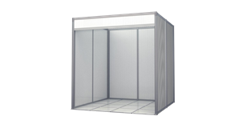
 | Column | Semi-curved column US $ 75 | 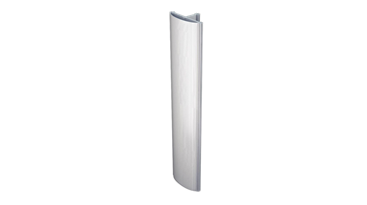
 | Column | Column curved US $ 75 | 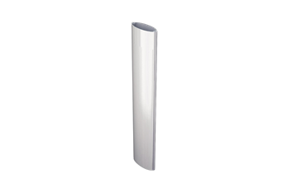
 | Column | Square column US $ 100 | 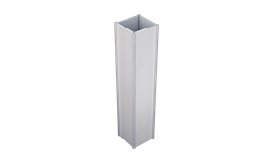
 | Column | Triangular Column US $ 75 | 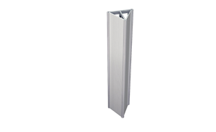
 | Separating fin | fin US $ 40 | 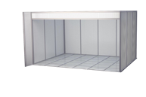  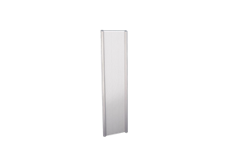
 | Counter | Desk US $ 50 | 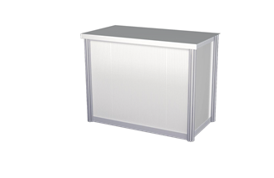
 | Counter | Counter US $ 75 | 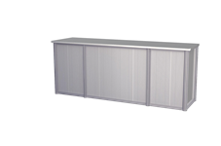
 | AREA LOUNGE | Lounge 3,00m X 3,00m  Masetero, 2 otomanes, 1 acrylic table, Curved sofa | 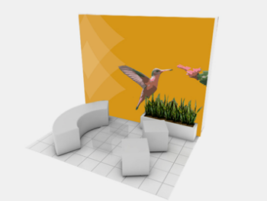
 | Bronze | Measures  2,00MX2,00MX2,40M  6 Panels: 0.98M X 2.32M  1 Fascia of 2.00M X 0.30M  1 Table with tablecloth 0,90M X 0,90M  1 Chair  (Does not include signage)  US $ 150 | 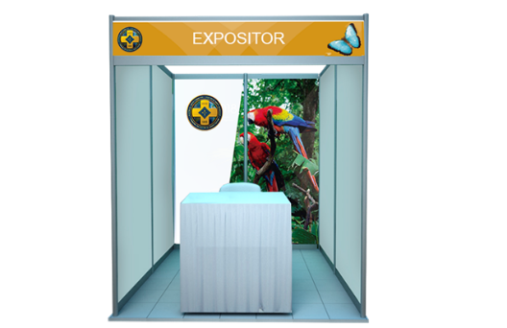
 | Bronze | Measures  3,00MX2,00MX2,40M  7 Panels: 0.98M X 2.32M  1 Fascia of 3.00M X 0.30M  1 Table with tablecloth 1,80M X 0,90M  2 Chairs  US $ 200 Dollars  (Does not include signage) | 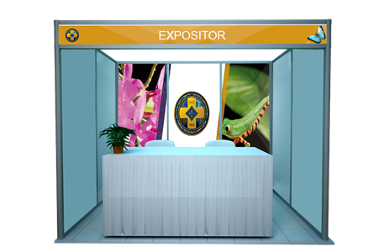
 | Silver | Measures  3,00MX2,00MX2,40M  2 Panels: 0.98M X 2.32M  2 Panels 0.46.5M X 2.32M  1 Counter 0.98M X 0.80M  Lateral 0.46.5M X 0.80M  2 Chairs  US $ 950 Dollars | 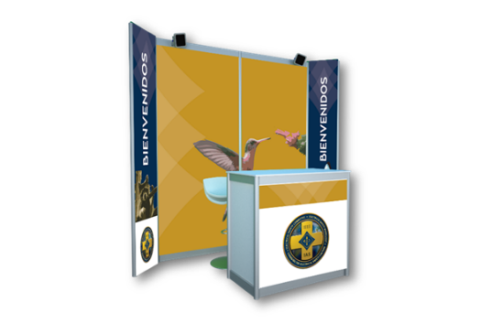
 | Gold | MEASURES:  3,00MX2,00MX2,40M  1 Wall: 2.50M X 2.40M  Sides: 0.15M  1 Column: 0.50M X 2.40M X  Sides: 0.50M  IT IS INCLUDED:  1. Shaker table with two cocktail shakers.  US $ 1350 Dollars | 