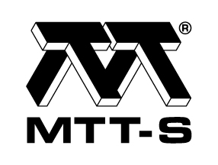
AP-S / MTT-S Joint Chapter Victoria
Technical Lecture

FEKO Application for High Frequency Simulation
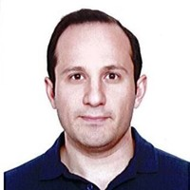

Presenter: Mahan Rudd, Altair Australia

Time: 5:30 (refreshments) for 6:00 - 7:00 pm talk
Thursday, 13 September 2018

Venue: Building 80, Level 3, Room 14 (080.03.014)
RMIT University, 445 Swanston Street, Melbourne, 3000

RSVP: Please register at Eventbrite. This is a free event and guest welcome

Abstract:

High frequency simulation is an inevitable part of any RF design these days. Simulation tools can help the designers to predict the performance before manufacturing and modify it to achieve an optimum result. Altair FEKO is a comprehensive computational electromagnetics (CEM) software used widely in the telecommunications, automobile, aerospace and defense industries. FEKO offers several frequency and time domain EM solvers under a single license. Hybridization of these methods enables the efficient analysis of a broad spectrum of EM problems, including antennas, microstrip circuits, RF components and biomedical systems, the placement of antennas on electrically large structures, the calculation of scattering as well as the investigation of electromagnetic compatibility (EMC). In this talk an overview of CEM solvers in FEKO will be presented. Then various applications will be demonstrated through different case studies.

Biography:

Mahan Rudd has got his Master's degree in telecommunication in 2009 and has been involved in high-frequency measurement and simulation since that time. He worked as a senior engineer at different test facilities from 2009-2017 performing EMC, EMR, SAR, Radio tests according to various Australian and international standards and developing compliance plans. Mahan joined
Altair engineering in 2017 to focus on EM modeling and simulation using Altair EM tools, FEKO and WinProp. He currently provides EM consultancy and support services to ANZ and ASEAN region. He has been part of the antenna research group at Royal Melbourne Institute of Technology (RMIT) since 2015, working towards his PhD degree.

For further information contact:

Enn Vinnal (e.vinnal@ieee.org) or Les Davey (les.j.davey@gmail.com), IEEE AP-S / MTT-S Chapter, Victoria Section)

