IEEE AP-S / MTT-S Joint Chapter Victoria
Technical Lecture

nbn’s Sky Muster satellite program, satellite payload and ground component

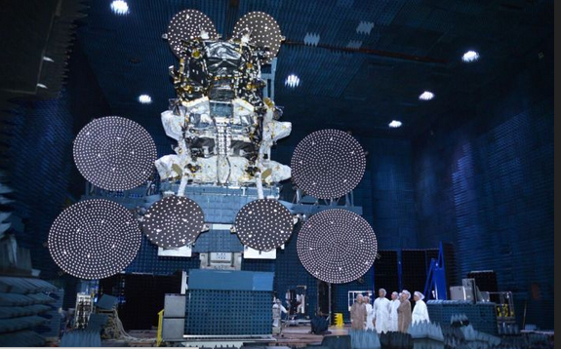

Presenter: Julia Dickinson
Executive Manager, Satellite Engineering, nbn co.

Time: 5:45 pm refreshments for 6:15 to 7:15 pm talk,
Thursday, 7th of June 2018

Venue: RMIT University, Building 80, Level 03, Room 14
445 Swanston Street, Melbourne, 3000.

RSVP: For catering purposes please register at Eventbrite
(free event and guests welcome)

Abstract:

This presentation will cover the nbn’s Sky Muster Satellite program with a focus on the Antenna & Communications Payload aspects of the satellites and the RF components of the ground segment. At time of launch the nbn satellites were two of the largest communications satellites ever built and with 10 ground stations in operation nbn has the largest ground segment of any company in Australia.

While the satellites are based on the LS1300 product line the communications payload was a bespoke design to meet the specifics of the Australian landscape. Aspects of the payload configuration will be discusse​d, ​the 3 year satellite build, integration & test program involved​, and ​current operations of the satellite network with a particular focus on Ka band​ propagation and ​
rain-fade mitigation techniques​.​

Biography:

Julia Dickinson commenced her career at AUSSAT as a Spacecraft Engineer on the Aussat A series satellites and then on the integration & test program for the AUSSAT/OPTUS B series satellites. Her responsibilities included Telemetry Command & Ranging (TCR), Electrical Power and the Communications Payload Subsystems. Julia later moved to Palo Alto to manage the OPTUS office based at Space Systems Loral during the integration and test program of the OPTUS C1 satellite. Upon her return to Australia Julia joined Worldspace in Melbourne, where in the role of Satellite Director she was responsible for operations of the Asiastar satellite.

Since joining nbn 8 years ago Julia has been a key architect in the Sky Muster satellite project focussing on the space segment. She has been involved in the programs since satellite requirements analysis and contract award for the Satellites with SSL and the launch contract with Arianespace. She then managed the team monitoring the satellite integration & test program and was nbn mission director for the launch on Ariane 5 launch vehicles.

With Sky Muster services operational as Executive Manager in Satellite Engineering, Julia is responsible for Capacity Management, Performance and Lifecycle of the Satellite System as well as the Regulatory aspects of spectrum licensing domestically and coordination of the nbn orbital filings.

For further information contact:

Les Davey (les.j.davey@gmail.com) or Enn Vinnal (e.vinnal@ieee.org), IEEE AP-S / MTT-S Chapter, Victoria Section)

