IEEE Victoria University Student Branch and AP-S / MTT-S Joint Chapter Victoria
Technical Lecture

Applications of future wireless communications :
V2X and wireless communications for for Industry 4.0 including URLLC

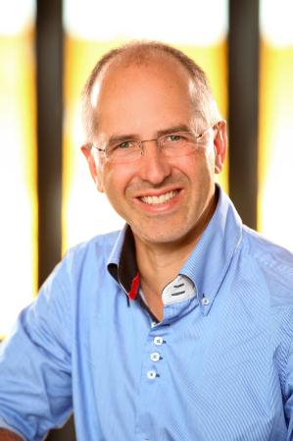

Presenter: Dr. Ing. Thomas Haustein
Fraunhofer-Institut für Nachrichtentechnik, Heinrich-Hertz-Institut
Department of Wireless Communications and Networks, Germany

Time: 2:30 pm refreshments for 3:00 to 4:15 pm talk,
Friday, 20th April 2018

Venue: Room 901 (CFL-FS0901) Lecture Theatre, Victoria University (City Campus),
301 Flinders Lane, Melbourne (entrance from 300 Flinders St or 301 Flinders Lane)

RSVP: For catering purposes please register at Eventbrite
(free event and guests welcome)

Abstract:

This presentation will cover upcoming 3GPP standardisation on V2x and wireless communications for for Industry 4.0 including Ultra Reliable Low Latency Communications.

Biography:

Department of Wireless Communications and Networks, Fraunhofer-Institut für Nachrichtentechnik, Heinrich-Hertz-Institut.

For further information contact:

Les Davey (les.j.davey@gmail.com) or Enn Vinnal (e.vinnal@ieee.org), IEEE AP-S / MTT-S Chapter, Victoria Section)

