IEEE AP-S / MTT-S Joint Chapter Victoria
Technical Lecture

Memories and thoughts of a recently retired RF Engineer

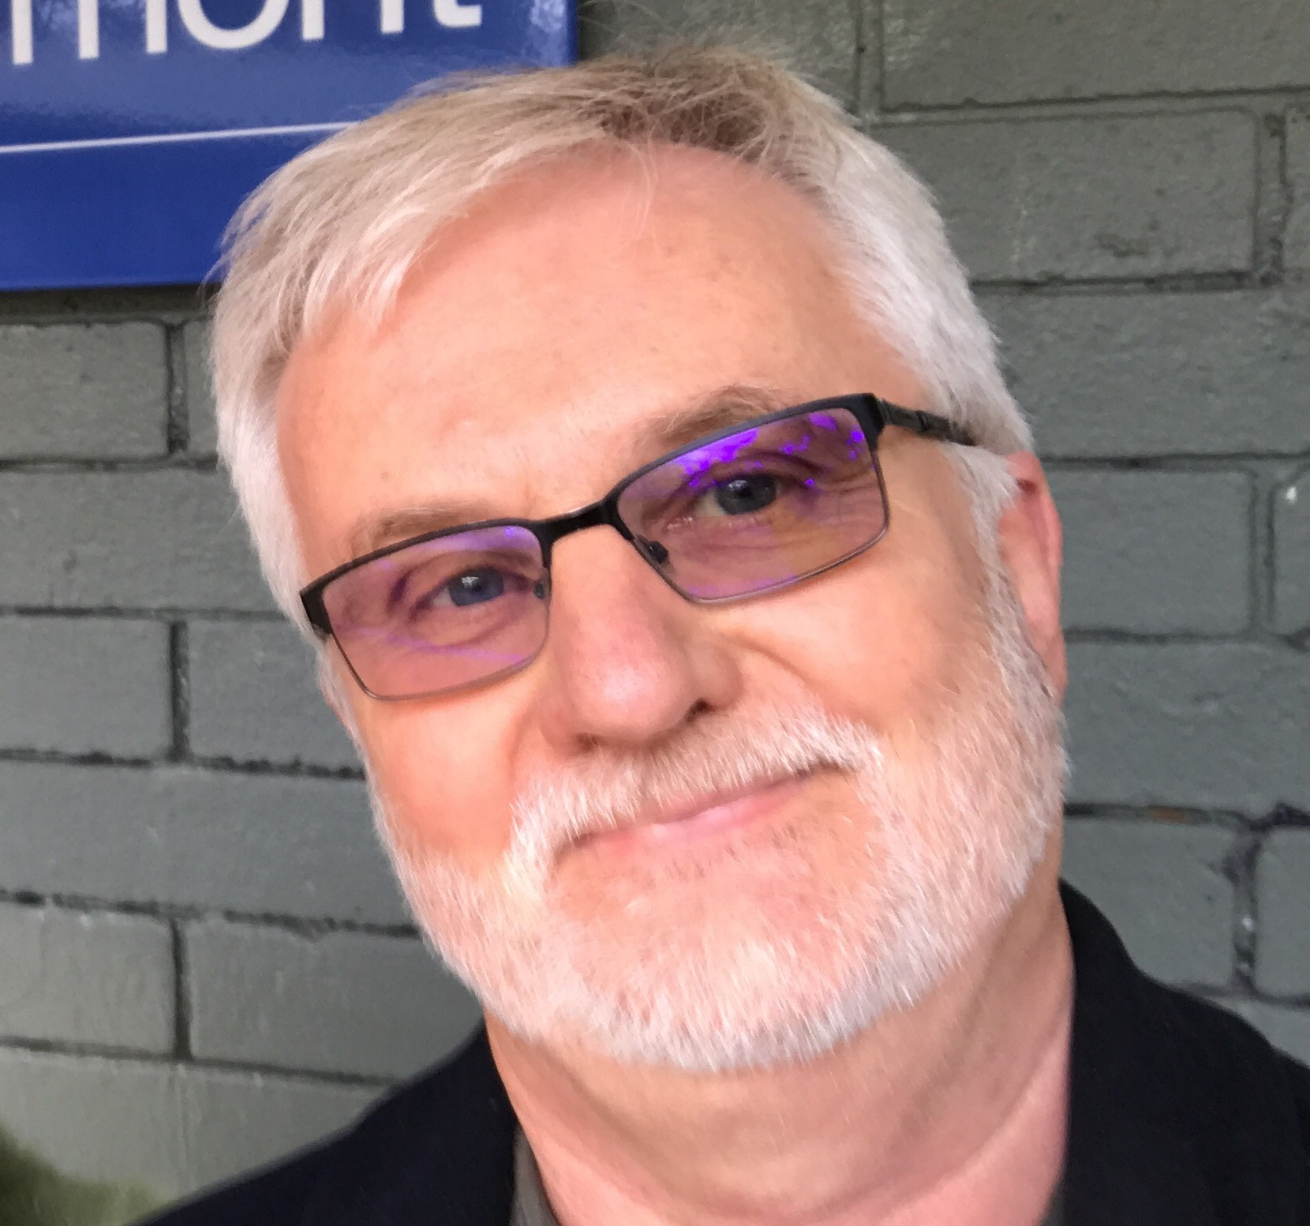

Presenter: Ing. Dieter Pelz

Time: 5:45 pm refreshments for 6:15 to 7:15 pm talk,
Thursday, 19th April 2018

Venue: RMIT University, Building 80, Level 05, Room 11
435-457 Swanston Street, Melbourne.

RSVP: For catering purposes please register at Eventbrite
(free event and guests welcome)

Abstract:

This talk is aimed at illustrating my 42-year career working as a RF & Microwave engineer in different roles and in different parts of the world. The past 22 years I spent in Australia, working for RFS (Radio Frequency Systems / Nokia) in the field of passive RF product design (antennas, antenna systems, microwave and RF filters, couplers, combining systems). My work at RFS probably culminated in 2017 with the installation of very innovatively Australian-designed UHF high-power TV transmitter combiners and antennas on One World Trade Centre in New York City.
In the course of my professional work, I was able to create a number of “world’s firsts” as a R&D engineer. In the talk, I shall recapitulate how some of these came about.
From my life as an engineer I can probably derive and extract a few items of good advice for young engineers and students. The question of specialisation versus wide knowledge will be addressed.
We live in a wireless world. At the same time there appears to be a global shortage of RF engineers. Few students include RF engineering in their studies. It is hoped, that my talk will create interest in the wide and challenging field of RF engineering.
About the speaker:
Mr. Dieter Pelz graduated from University of Applied Sciences and Arts, Dortmund (Germany) in 1974. He worked for more than 42 years in the field of RF & microwave engineering, broadcasting, sales and finally, R&D manager in many countries such as Germany, Sri Lanka, India, and Australia. After 42 years of successful career in industry, he retired as R&D Manager, Radio Frequency Systems (RFS), Melbourne, Australia in December 2017. Dieter is a Bell-Labs endorsed DMTS since 2012. He holds many patents and has scholarly contributions in RF/microwave filter design, antennas and microwave passive design. He is well regarded as a research scientist in the field in both industry and university worldwide.

For further information contact:

Les Davey (les.j.davey@gmail.com) or Enn Vinnal (e.vinnal@ieee.org) IEEE AP-S / MTT-S Chapter, Victoria Section)

