Preparation of Papers for IFAC Conferences & Symposia:
Use Title Case for Paper Title
First A. Author*. Second B. Author, Jr.** Third C. Author***
*National Institute of Standards and Technology, Boulder, CO 8030
USA (Tel: 303-555-5555; e-mail: author@boulder.nist.gov).
**Colorado State University, Fort Collins, CO 80523 USA (e-mail:
author@lamar.colostate.edu)
*** Electrical Engineering Department, Seoul National University
Seoul, Korea, (e-mail: author@snu.ac.kr)}
Advisor: Name and Surname
Abstract: These instructions give you guidelines for preparing papers for IFAC conferences. Use this document as a template to compose your paper if you are using Microsoft Word 2016 or later. Otherwise, use this document as an instruction set. Please use this document as a “template” to prepare your manuscript. For submission guidelines, follow instructions on paper submission system as well as the Conference website.
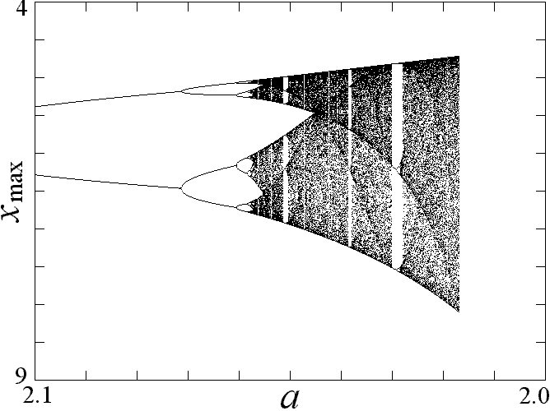
Keywords: Include a list of 3-5 keywords.
Figure 1. Bifurcation: Plot of local maxima of x with damping a decreasing.

1. INTRODUCTION
This document is a template for Microsoft Word 2016 or later. If you are reading a paper version of this document, please download the electronic file, ifacconf.docx. If your paper is intended for an IFAC event, please contact the editor of the meeting concerning acceptable word processor formats for that particular event. Please do not put any running header/footer or page number in the submitted paper.
You can type over sections of this document or cut and paste from another document and then use markup styles. (for example, the style at this point in the document is “Text”). Highlight a section that you want to designate with a certain style, and then select the appropriate name on the style menu. The style will adjust your fonts and line spacing. Do not change the font sizes or line spacing to squeeze more text into a limited number of pages. Use italics for emphasis; do not underline.

1.1 A subsection
Bifurcation: Plot of local maxima of x with damping a decreasing (Fig. 1).
Insert images in Word.
IFAC will not do any final formatting of your paper. Your manuscript should be ‘camera-ready.’ Page limits vary from conference to conference. Please observe the page limits of the conference for which your paper is intended. Please do not modify margins. If you are creating a document on your own, please observe the margins as listed in Table 1.

1.2 Another Subsection
Text of the subsection.

2. PROCEDURE FOR PAPER SUBMISSION

2.1 Review stage
Please use this document as a template to prepare your manuscript. For submission guidelines, follow instructions on the paper submission system as well as the conference website.
Note that conferences impose strict page limits, so it will be better for you to prepare your initial submission in the camera-ready layout so that you will have a good estimate for the paper length. Additionally, the effort required for final submission will be minimal.

2.2 Final stage
Authors are expected to mind the margins diligently. Conference papers need to be stamped with conference data and paginated for inclusion in the proceedings. If your manuscript bleeds into margins, you will be required to resubmit and delay the proceedings preparation in the process.

2.3 Page margins
All dimensions are in centimeters.
Table 1. Page margins
Page | Top | Bottom | Left/Right
First | 3.5 | 2.5 | 1.5
Others | 2.5 | 2.5 | 1.5

It is very important to maintain these margins. They are necessary to insert conference information and page numbers for the proceedings.

2.4 Figures and PDF creation
All figures must be embedded in the document. When you include the image, make sure to insert the actual image rather than a link to your local computer. As far as possible, use standard PDF conversion tools. Native ‘Save as PDF’ or Adobe Acrobat give best results. It is important that all fonts be embedded/subsetted in the resulting PDF.

2.5 License agreement form
IFAC articles are published in IFAC-PapersOnline under a Creative-Commons License. Authors must fill in a license agreement form on the submission platform at the time of uploading the final version of their papers.

3. MATH
Use the native Word equation tools by selecting Insert > Equation on the Menu bar.

4. UNITS
Use SI as primary units. Other units may be used as secondary units in parentheses. This applies to papers on data storage. For example, write “15 Gb/cm² (100 Gb/sq in).” An exception is when English units are used as identifiers in trade, such as “3.5 in disk drive.” Avoid combining SI and CGS units, such as current in amperes and magnetic field in oersteds. This often leads to confusion because equations do not balance dimensionally. If you must use mixed units, clearly state the units for each quantity in an equation.
The SI unit for magnetic field strength H is A/m. However, if you wish to use units of T, either refer to magnetic flux density B or magnetic field strength symbolized as µ0H. Use the center dot to separate compound units, e.g., “A·m².”

5. HELPFUL HINTS

5.1 Figures and tables
Figure axis labels are often a source of confusion. Use words rather than symbols. As an example, write the quantity “Magnetization,” or “Magnetization M,” not just “M.” Put units in parentheses. Do not label axes only with units. For example, write “Magnetization (A/m)” or “Magnetization (Amm1),” not just “A/m.” Do not label axes with a ratio of quantities and units. For example, write “Temperature (K),” not “Temperature/K.”
Multipliers can be especially confusing. Write “Magnetization (kA/m)” or “Magnetization (103 A/m).” Do not write “Magnetization (A/m) / 1000” because the reader would not know whether the top axis label in Fig. 1 meant 16000 A/m or 0.016 A/m. Figure labels should be legible, approximately 8-to-12-point type.

5.2 References
Use Harvard style references (see at the end of this document). Footnotes should be avoided as far as possible.
Please note that the references at the end of this document are in the preferred referencing style. Papers that have not been published should be cited as “unpublished.” Capitalize only the first word in a paper title, except for proper nouns and element symbols.

5.3 Abbreviations and acronyms
Define abbreviations and acronyms the first time they are used in the text, even after they have already been defined in the abstract. Abbreviations such as IFAC, SI, ac, and dc do not have to be defined. Abbreviations that incorporate periods should not have spaces: write “C.N.R.S.,” not “C. N. R. S.” Do not use abbreviations in the title unless they are unavoidable (for example, “IFAC” in the title of this article).

5.4 Equations
Number equations consecutively with equation numbers in parentheses flush with the right margin, as in (1). First use the equation tools to create the equation. Then select the “Equation” mark-up style. Press the tab key and write the equation number in parentheses. To make your equations more compact, you may use the solidus ( / ), the exp function, or appropriate exponents. Use parentheses to avoid ambiguities in denominators. Punctuate equations when they are part of a sentence, as in
$$\begin{aligned}\int_{0}^{r_{2}}{F\left(r,ϕ\right) dr dϕ} = \\ \left[σ r_{2}/2μ_{0}\right]⋅ \\ \int_{0}^{∞}{\exp\left(-λ\left|z_{j}-z_{i}\right|\right)λ^{-1}J_{1}\left(λr_{2}\right)J_{0}\left(λr_{i}\right)dλ}\#\left(1\right)\end{aligned}$$
Be sure that the symbols in your equation have been defined before the equation appears or immediately following. Italicize symbols (T might refer to temperature, but T is the unit tesla). Refer to “(1),” not “Eq. (1)” or “equation (1),” except at the beginning of a sentence: “Equation (1) is …”

5.5 Other Recommendations
Use one space after periods and colons. Hyphenate complex modifiers: “zero-field-cooled magnetization.” Avoid dangling participles, such as, “Using (1), the potential was calculated.” [It is not clear who or what used (1).] Write instead, “The potential was calculated by using (1),” or “Using (1), we calculated the potential.”
A parenthetical statement at the end of a sentence is punctuated outside of the closing parenthesis (like this). (A parenthetical sentence is punctuated within the parentheses.) Avoid contractions; for example, write “do not” instead of “don’t.” The serial comma is preferred: “A, B, and C” instead of “A, B and C.”

6. CONCLUSIONS
A conclusion section is not required. Although a conclusion may review the main points of the paper, do not replicate the abstract as the conclusion. A conclusion might elaborate on the importance of the work or suggest applications and extensions.

REFERENCES
- G. Eason, B. Noble, and I. N. Sneddon, “On certain integrals of Lipschitz-Hankel type involving products of Bessel functions,” Phil. Trans. Roy. Soc. London, vol. A247, pp. 529–551, April 1955. (references)
- J. Clerk Maxwell, A Treatise on Electricity and Magnetism, 3rd ed., vol. 2. Oxford: Clarendon, 1892, pp.68–73.
- I. S. Jacobs and C. P. Bean, “Fine particles, thin films and exchange anisotropy,” in Magnetism, vol. III, G. T. Rado and H. Suhl, Eds. New York: Academic, 1963, pp. 271–350.
- K. Elissa, “Title of paper if known,” unpublished.
- R. Nicole, “Title of paper with only first word capitalized,” J. Name Stand. Abbrev., in press.
- Y. Yorozu, M. Hirano, K. Oka, and Y. Tagawa, “Electron spectroscopy studies on magneto-optical media and plastic substrate interface,” IEEE Transl. J. Magn. Japan, vol. 2, pp. 740–741, August 1987 [Digests 9th Annual Conf. Magnetics Japan, p. 301, 1982].
- M. Young, The Technical Writer’s Handbook. Mill Valley, CA: University Science, 1989.

