#### Power System Basics and Emerging Technologies

#### For

**Non-Power Engineering Professionals**

##### This is the third run of the “Basics” series of courses for non-power engineering professionals organised by IEEE Power & Energy Society (Singapore Chapter).

##### The power system has played a very important role in our nation building and economic growth. Everything that impacts our lives, from where we live to where we work, from our government to our infrastructure, is dependent on a secure and reliable supply of electricity. With the liberalisation of electricity industry and the increasing understanding of the importance of a reliable, secure and efficient power system in contributing to sustainable developments in the economy, society and infrastructures, such as transportation, water supply, etc., more and more non-power engineering professionals who work in or with the electric power industry are required to have a basic understanding of the power system, how it operates or how it is evolving with the emerging trends leading to a smart and intelligent grid. This Power System Course is designed with such needs in mind and is focused on the power system in Singapore.

##### Registration Information on Page 7

##### Early Bird Registration Ends 10 January 2018

##### *Who Should Attend:*

##### This course is designed for those who work within the electricity industry in a non-power engineering capacity, or are transitioning to the electricity industry from another industry. Others who would benefit from the course are those who work with the electricity industry, such as board members, business executives, energy traders, energy service and large electricity consuming company staff members, government officials, regulatory or legislative staff members, public affairs administrators, media professionals, lawyers, economists, accountants, business consultants or anyone with an interest in learning about the power systems upon which we all depend.

##### *Course Date:*

##### Friday, 19 January 2018

##### from 9:00 a.m. to 5:30 p.m.

##### [Registration starts at 8:30 a.m.]

##### 

##### *Description:*

##### This course is aimed to provide a comprehensive understanding of the fundamentals in power systems, from basic electrical terminology and components involved in generating, transmitting, and distributing electric power to operation and control of power system and how prices of electricity energy are determined with specific reference to the power system and electricity markets in Singapore.

##### The course will explain the concepts and systems in simple to understand language with an interactive discussion session at the end for participants to interact with the instructors. Topics to be covered in the course include generation technologies, main features and characteristics of transmission and distribution networks, connections of consumer’s electrical Installations to electricity networks, operation and control of power system, concept of smart grid, energy management, integration of renewable sources of energy to the grid, etc.

##### Registrants to this course are encouraged to send their queries or specific issues on power system to email address: [kangsengseow@gmail.com](mailto:kangsengseow@gmail.com). The trainers will try to answer these queries or specific issues on power system during the course or at the interactive discussion session at the end of the course.

##### *Trainers Bios:*

##### WANG PENG, PhD

##### *Wang Peng* received his B.Sc. degree from Xian Jiaotong University, China, in 1978, the M.Sc. degree from Taiyuan University of Technology, China, in 1987, and the M.Sc. and Ph.D. degrees from University of Saskatchewan, Canada, in 1995 and 1998, respectively. Currently, he is a Professor in School of Electrical and Electronic Engineering of Nanyang Technological University, Singapore. His research areas include power system planning and operation, reliability, voltage stability, power market, smart grid, micro grid, energy management system and renewable energy conversion systems. He was a PI or Co-PI of national and international research projects related to power system planning and operation, renewable source utilization and Micro grids. He is working on two research projects on micro grids and electric vehicles. He has done some consulting works for industries such as Vestas and Pansonics. He has over 30-years university teaching experience in China, Canada and Singapore. The courses cover a wide range of electrical and electronics engineering from basic electric and electronic circuit to power systems. He is currently serving as an Associate Editor of IEEE Transaction on Smart Grid. He has published over 150 journal and conference papers on power system planning and operation. He is a Senior Member of IEEE.

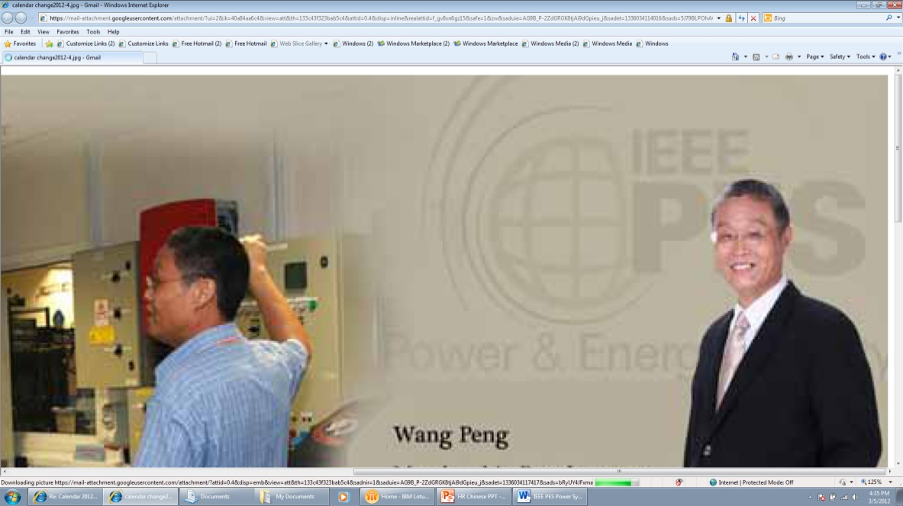

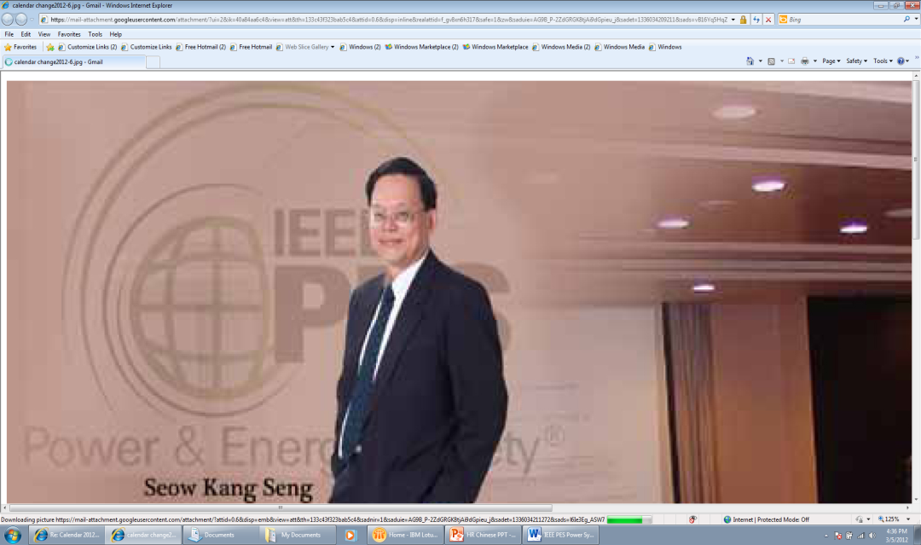

##### SEOW KANG SENG, PE

##### *Seow Kang Seng* is a Singapore Registered Professional Engineer in Electrical Engineering with expertise in planning, design and implementation of numerous power system and engineering projects. He is a 42-year veteran of the utility industry, with strategic, planning, operational and consulting experience. He has provided client solutions in grid code harmonization, substation upgrading, strategic planning, technical analysis and project implementation. Er. Seow started work in the then Electricity Department of Public Utilities Board in 1975 and left in 1995 to put in charge of new electricity supply business under the Singapore Power group in 1995. He was Deputy Managing Director of SP Services Ltd before he left the company in 2003. Er. Seow set up his consultancy practice subsequently and joined Energy Market Authority as Director (Inspectorate) in June 2006. He was also the Deputy Chairman of the Project Committee for the Electricity Vending System Pilot Project, which was completed successfully in 2009 and the joint inventor for the patent pending Utility Vending System. Er. Seow became the Project Director for the Pulau Ubin Clean and Renewable Energy Technologies Test-bedding Project in 2009 before he left EMA in 2011. Er. Seow resumed his consultancy practice in July 2011 and joined DNV GL as Principal Consultant of Clean Energy Centre in January 2015. He is a Fellow of Institution of Engineers Singapore and Senior Member of IEEE.

##### TAN TECK LEE, PE

##### *Tan Teck Lee* has more than 30 years of experience in the power and energy industry. His experience includes the site installation and commissioning of power transmission network equipment, transmission projects management, condition monitoring of power systems equipment, power quality investigations, impact analysis of voltage dips and power systems network studies. He is actively involved in overseas training and consultancy services. Teck Lee graduated with a First Class Honors Degree in Electronics & Electrical Engineering from the University of Glasgow, UK, and was awarded the prestigious Medal and Prize for being the most distinguished graduate in the Faculty of Engineering. He is a regular reviewer for IEEE PES Transaction Journals and Technical Chairman for International Conferences. In recognition for his outstanding professional and leadership contributions to the power engineering profession, Teck Lee received the Outstanding Engineer Award from IEEE Power and Energy Society “United Kingdom & Republic of Ireland (UKRI) Chapter” and “Singapore Chapter” in 2000 and 2009 respectively. He is a registered Professional Electrical Engineer in Singapore and a Senior Member of IEEE.

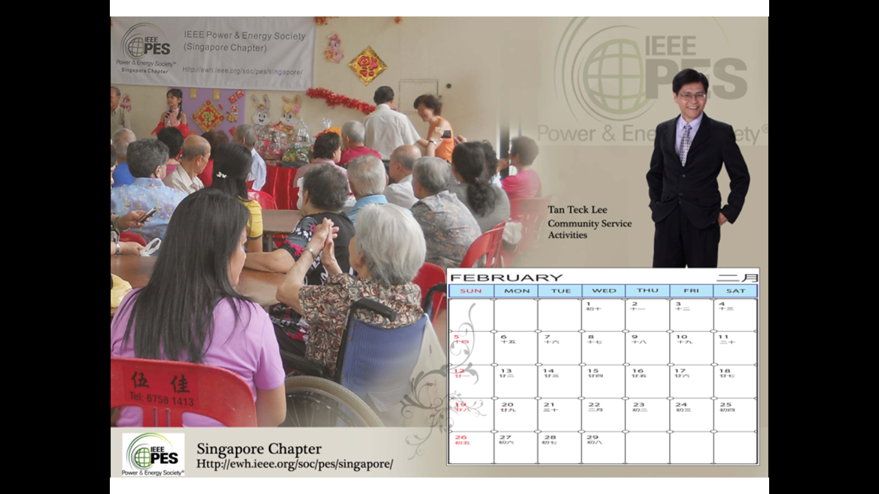



##### KWAN KIAN HOONG, PhD

##### *Kwan Kian Hoong* is a Senior Lecturer with the School of Engineering, Temasek Polytechnic. He received his B.Eng. (Electrical & Electronic) and PhD degrees from Nanyang Technological University. He has been an academia, engineer, a policy maker as well as a researcher. He has also published several international journals and conference papers. He was involved in the planning, development and research of several various smart grid projects, including major ones in Singapore. For his academic achievements, he has won the IEEE Power Engineering Chapter Gold Medal and the Singapore Power Book Prizes. For his achievements in Smart Grids developments, he has also won the Singapore Ministry of Trade and Industry Innovation Award and the Smart Grid Initiative Award.

##### TEH GEK HUAT, MSc

##### *Teh Gek Huat* is a Senior Lecturer with the Electrical Engineering

##### Division, Ngee Ann Polytechnic. He received his B.Eng. (Electrical)

##### degree from Singapore University in 1974, and the M.Sc. degree

##### from National University of Singapore in 1991. He had worked with

##### GEC and Guthrie Engineering and was the site project manager undertaking large international projects like Royal Malaysia Lumut

##### Naval Base high voltage distribution network.

##### He set up the High Voltage Training Center at Ngee Ann Polytechnic in 2000 for the training of electrical engineers and

##### technicians from the industry.



##### THILLAINATHAN LOGENTHIRAN, PhD

##### *Thillainathan Logenthiran* obtained his B.Sc. degree in Electrical and Electronic Engineering from the University of Peradeniya, Sri Lanka and Ph.D. degree in Electrical Engineering from the National University of Singapore (NUS), Singapore. He worked at the University of Strathclyde, United Kingdom as a postdoctoral researcher. In January 2014, he joined as a lecturer at the school of the Electrical and Electronic Engineering, Newcastle University, Singapore campus. His research areas of interest include smart grid, micro grid, renewable energy resources, applications of computational intelligent techniques & intelligent Multi-Agent System for power systems. He published several internationally referred journal papers, book chapters and conference papers on power system engineering and applications of computational intelligent techniques. Logenthiran is a senior member of IEEE and a member of IET and IES. He has got several awards and scholarships including the first prize award in Siemens Smart Grid Innovation Contest 2011.

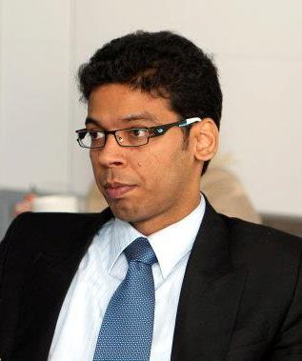

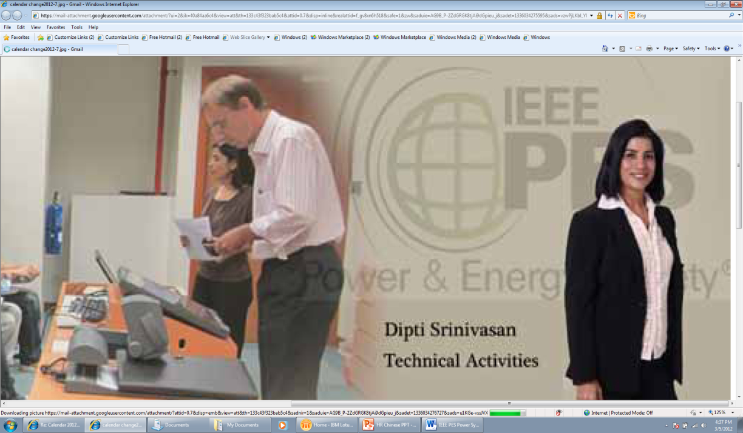

##### DIPTI SRINIVASAN, PhD

##### *Dipti Srinivasan* obtained her M.Eng. and Ph.D. degrees in Electrical Engineering from the National University of Singapore (NUS) in 1991 and 1994 respectively. She worked at the University of California at Berkeley’s Computer Science Division as a postdoctoral researcher from 1994 to 1995. In June 1995, she joined the faculty of the Electrical & Computer Engineering department at the National University of Singapore, where she is now a Professor. From 1998-1999 she was a Visiting Faculty in the Department of Electrical & Computer Engineering at the Indian Institute of Science, Bangalore, India. Her research interest is in the development of hybrid neural network architectures, learning methods and their practical applications for large complex engineered systems, such as the electric power system and urban transportation systems. She is currently serving as an Associate Editor of IEEE Transaction of Neural Networks and IEEE Transactions on Intelligent Transportation Systems. Dipti is a Senior Member of IEEE, and was awarded the IEEE PES Outstanding Engineer award in 2010. At the ECE department of National University of Singapore, she has been teaching courses in the areas of computational intelligence, and power & energy systems. She was the winner of NUS Annual Teaching Excellence Award in year 2007, 2008 and 2009, and was placed on the Honours list in 2010. She is the recipient of 2010 Engineering Educator Award from the Faculty of Engineering, NUS.

##### ANURAG SHARMA, PhD

##### *Anurag Sharma* received Bachelor’s Degree in Electrical Engineering from Malaviya National Institute of Technology (MNIT) Jaipur, India, and the PhD degree from Department of Electrical and Computer Engineering, National University of Singapore (NUS). He is currently a lecturer at School of Electrical and Electronic Engineering at Newcastle University, Singapore campus. Before joining Newcastle University, he worked as a Research Engineer at Green Energy Management and Smart Grid Research Center [GEMS] @ NUS. His main research interests include, service restoration in distribution systems, energy management in Micro-grids, distributed energy resources - integration and their application for various ancillary services, and multi-agent system application in power systems. He is an active committee member of IEEE PES Singapore Chapter since January 2016. At Newcastle University Singapore, he is teaching courses in areas of power and energy systems and computational intelligence in power systems.

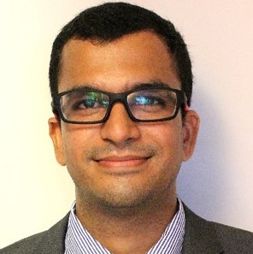

For more details, please refer to <http://www.ewh.ieee.org/soc/pes/singapore/>

##### *Registration Fee:* $540 per registrant

##### *Early Bird Registration Fee:* $490 per registrant for registrants who register and pay on or before 10 January 2018.

##### *IEEE/IES Member Discounts:* $440 per registrant for registrants who register and pay on or before 10 January 2018 or

##### $490 per registrant for registrants who register and pay after 10 January 2018

##### *Group Discounts:* $440 per registrant for companies or organizations registering 5 or more registrants from the same company or organization on or before 10 January 2018 [*Full registration fee of $540 per registrant will be charged if payment is only made after* 10 January 2018*.*]

##### *Note: Registration fee will include lecture materials, lunch and two coffee/tea breaks.*

##### Cancellations made in writing prior to 12 January 2018 will be fully refunded, less a $50 cancellation fee. There will be no refunds after 12 January 2018. If a registrant is unable to attend, the fee may be used by a substitute.

##### IEEE Power and Energy Society (Singapore Chapter) reserves the right to cancel this course without providing explanation. In the unlikely event of a cancellation, registrants will receive a full refund for the registration fee only.

##### Registration Form

**Course Title:** **Power System Basics and Emerging Technologies for Non-Power Engineering Professionals**

# Date: Friday, 19 January 2018

**Time: 9:00 a.m. to 5:30 p.m**. [Registration commences at 8:30 a.m.]

**Venue: Orchard Hotel**

442 Orchard Road, Singapore 238879. Tel: 6734 7766

<http://www.millenniumhotels.com.sg/orchardhotelsingapore/index.html>

Registration Fee: $540 per registrant

Early Bird Discounts: $490 per registrant for registrants who register and pay on or before **10 January 2018**.

IEEE/IES Member Discounts: $440 per registrant for registrants who register and pay on or before **10 January 2018** or

$490 per registrant for registrants who register and pay after **10 January 2018**

Group Discounts: $440 per registrant for companies or organizations registering 5 or more registrants from the same company or organization on or before **10 January 2018**. [Full registration fee of $540 per registrant will be charged if payment is only made after **10 January 2018**.]

Note: Registration fee will include lecture materials, lunch and two coffee/tea breaks.

Cancellations made in writing prior to **12 January 2018** will be fully refunded, less a $50 cancellation fee. There will be no refunds after **12 January 2018**. If a registrant is unable to attend, the fee may be used by a substitute.

IEEE Power and Energy Society (Singapore Chapter) reserves the right to cancel this course without providing explanation. In the unlikely event of a cancellation, registrants will receive a full refund for the registration fee only.

To register, please send this registration form and registration fee to:

Dr Thillainathan Logenthiran

## Newcastle University (Singapore campus),

## SIT Building @ Nanyang Polytechnic

## 172A Ang Mo Kio Avenue 8 #05-01

## Singapore 567739

## Tel: 6908 6070

## Email: [t.logenthiran@newcastle.ac.uk](mailto:t.logenthiran@newcastle.ac.uk)

Payment of registration fee shall either be made by cheque payable to “IEEE Power Chapter” or internet banking transfer to DBS bank account number: 0060053467.

**Course Title:** **Power System Basics for Non-Power Engineering Professionals**

# Date: Friday, 19 January 2018

**Time: 9:00 a.m. to 5:30 p.m**. [Registration commences at 8:30 a.m.]

**Registrant Particulars**

Name: ______________________________________________________________

Designation: ______________________________________________________________

Affiliation/Organization: ______________________________________________________

Postal Address: _____________________________________________________________

__________________________________________________________________________

IEEE*/IES* Membership Number:_______________________________________________

Email:______________________________________________________________________

Handphone: _______________________________________________________________

Deskphone: _________________________________________________________________

Bank Cheque No* / Internet Banking Transfer* : ____________________________________

Food: Halal Set Lunch* / Vegetarian Set Lunch* / Buffet Lunch*

* Please delete if not applicable.