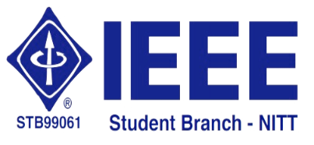 | National Institute of Technology,  Tiruchirappalli – 620 015 | 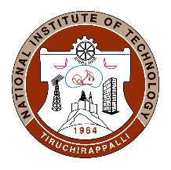

27.06.2020
IEEE Student Branch Activity Report for June 2020 – Technical Talk by Dr. Chandra Shekar Lakshminarayanan on 27.06.2020

The IEEE Student Branch of NIT-Tiruchirappalli in association with IEEE-Computer Society chapter organized a technical talk via WebEx Meetings on “Reinforcement Learning: The frontier of Artificial Intelligence” by Dr. Chandra Shekar Lakshminarayanan, Assistant Professor, Department of CSE, IIT Palakkad. A registration form was created for the event, using which participants registered their basic details. Meeting link was shared with the registered participants.
Dr. Lakshminarayanan started the session by introducing examples of state of the art artificial intelligence (AI) like image tagging, self driving cars, human speech recognition & synthesis and playing games like chess. He contrasted the smart programs that drive these artificially intelligent systems with the conventional computer programs and highlighted the former’s ability to learn, adapt and respond to new situations. Dr. Lakshminarayanan then asked the participants to categorise several real world applications like Google ad placement, spam filtering, self-driving cars, stock and weather prediction into static or dynamic tasks and prediction or control tasks. After several incorrect attempts from the participants, Dr. Lakshminarayanan elucidated the logic behind classifying such AI tasks and this was a major takeaway from the session. He then moved on to the popular topic of Machine Learning and discussed data driven methods to solve AI tasks. He then spoke in detail about Reinforcement Learning and explained several methods to solve AI control tasks. The technical talk was attended by UG, PG and Ph.D. scholars from CSE, EEE and ECE departments of NIT Tiruchirappalli. Throughout the session, Dr. Lakshminarayanan had stressed on the role of probability and decision theory in developing AI systems and encouraged the students to focus on these areas if they wished to pursue a career in AI.

Technical talk's video can be found in the link:
https://drive.google.com/drive/folders/1r0IREfNr1178Cqp4vPTeGolnR_ou7ri6

