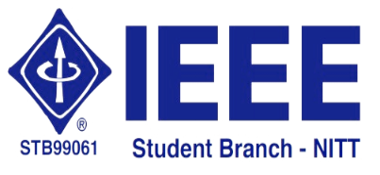 | National Institute of Technology,  Tiruchirappalli – 620 015 | 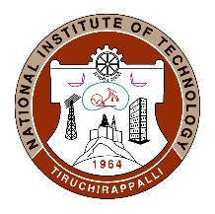

02.06.2020
IEEE Student Branch Activity Report for June 2020 – Technical Talk by Dr. N.V.S.N. Sarma on 02.06.2020

The IEEE Student Branch of NIT-Tiruchirappalli in association with Institute of Engineers (IEI India) - Tiruchirappalli Local Centre (TLC) and Tamilnadu State Centre (TNSC) organized a technical webinar via CISCO Webex Meetings application on the topic “Achieving Sustainable Development Goals through ICTs” by Dr. N.V.S.N.Sarma, Director, IIIT Tiruchirappalli, Tamil Nadu.
Dr. Sarma started with the definition of sustainable development. He then detailed the seventeen sustainable development goals (SDG) like eradicating poverty and hunger, improving quality of health and education, availability of affordable and clean energy etc. He particularly highlighted the need for responsible development by judicious consumption of natural resources and action on climate change. Dr. Sarma then moved on to the technical domain of Information & Communications Technology (ICT), which played a major role in bringing about the Information Age. The information age is expected to give way to the Age of Sustainable Development. The role ICT could play in enabling the arrival of this new age by accelerating the attainment of SDG was the crux of this session. Dr. Sarma discussed the steps to be taken in that direction like developing a basic ICT infrastructure and improving the access to mobile broadband services. Towards the end of the session, Dr. Sarma discussed some of the research possibilities like sustainability science, research in context of social-ecological systems and ICT framework for SDG. The technical talk was attended by UG, PG and Ph.D. scholars from CSE, EEE and ECE departments of NIT Tiruchirappalli. Engineers affiliated to IEI were also in attendance.

Technical talk's video can be found in the link:
https://drive.google.com/drive/folders/1DEStuZ6Pk3zTSqtbk3tvUEuPPgi0z9fs

