**EVENT REPORT**

**“INNOVISION”**

**Date of Conduction** : 6th October, 2023 **Mode of Conduction** :Offline **Time** : 10 AM

The Women in Engineering (WIE) group conducted an event named Ideathon where participants pitched in their ideas. The event was held offline and was open to all. The participants were required to submit their ideas on the given theme within a stipulated time frame. The theme of the event was “Innovative Solutions for Sustainable Development Goals (SDGs)”.

The event was held in the view of IEEE Day and was a huge success with over 20 participants . The participants came up with innovative ideas that could help achieve the SDGs. The ideas were evaluated by a panel of judges based on their feasibility, impact, and originality.The judges and other participants asked questions to the participants to better understand their ideas and provide feedback.

The top 3 ideas were selected for further development and implementation. The winners were awarded cash prizes and certificates of appreciation.

Overall, the Ideathon event conducted by WIE was a great success and helped promote innovation and creativity among the participants.

The day's session ended on a positive note, with the children asking the volunteers questions about their education and expressing their interest in pursuing similar paths. The volunteers said their goodbyes as the children marched out with a wholesome experience.

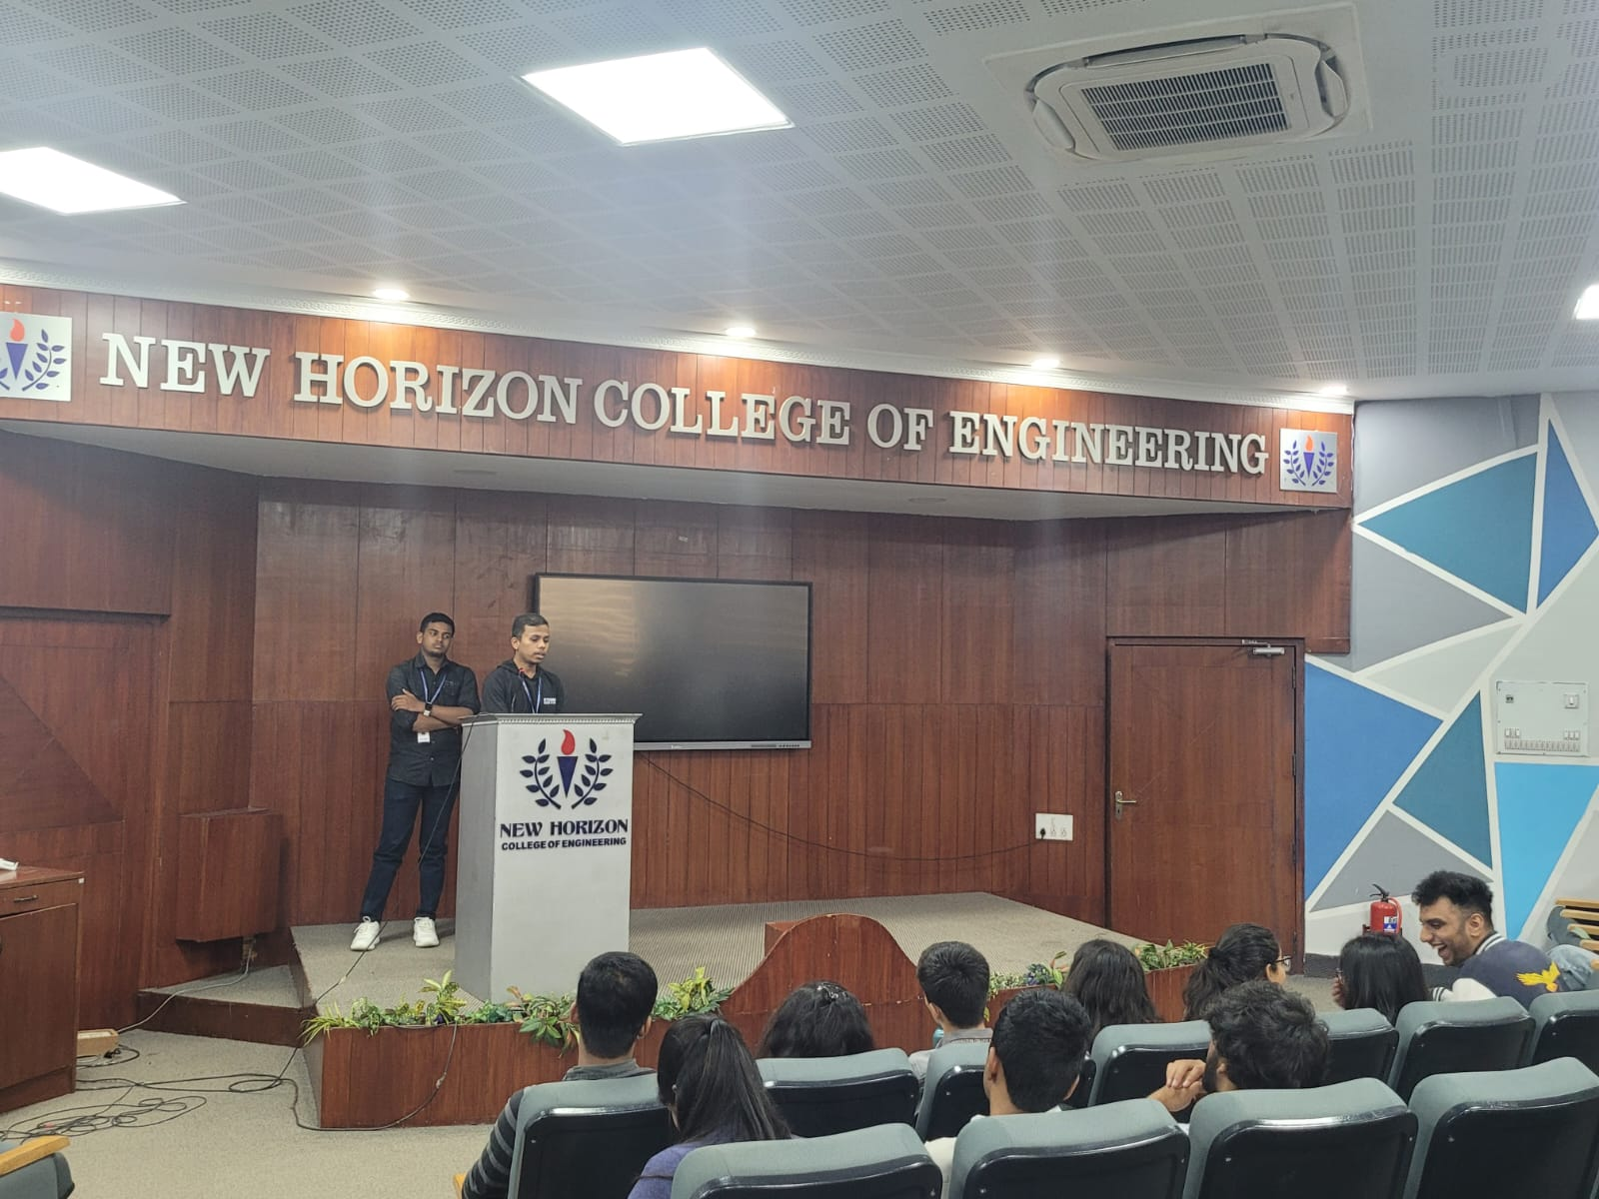

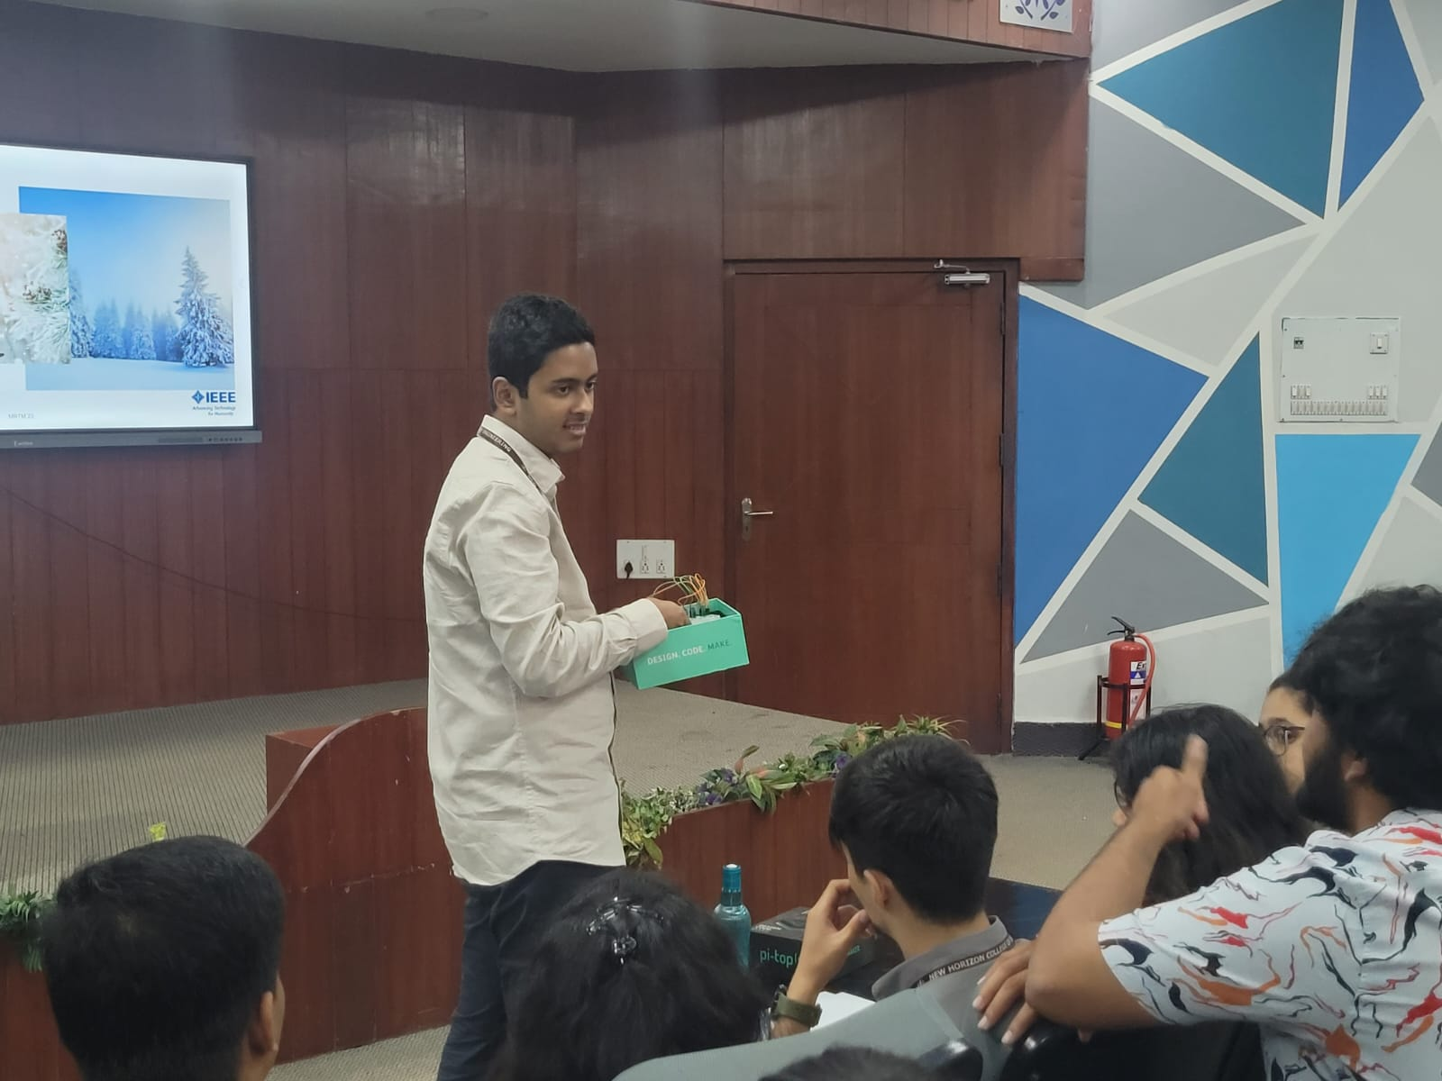

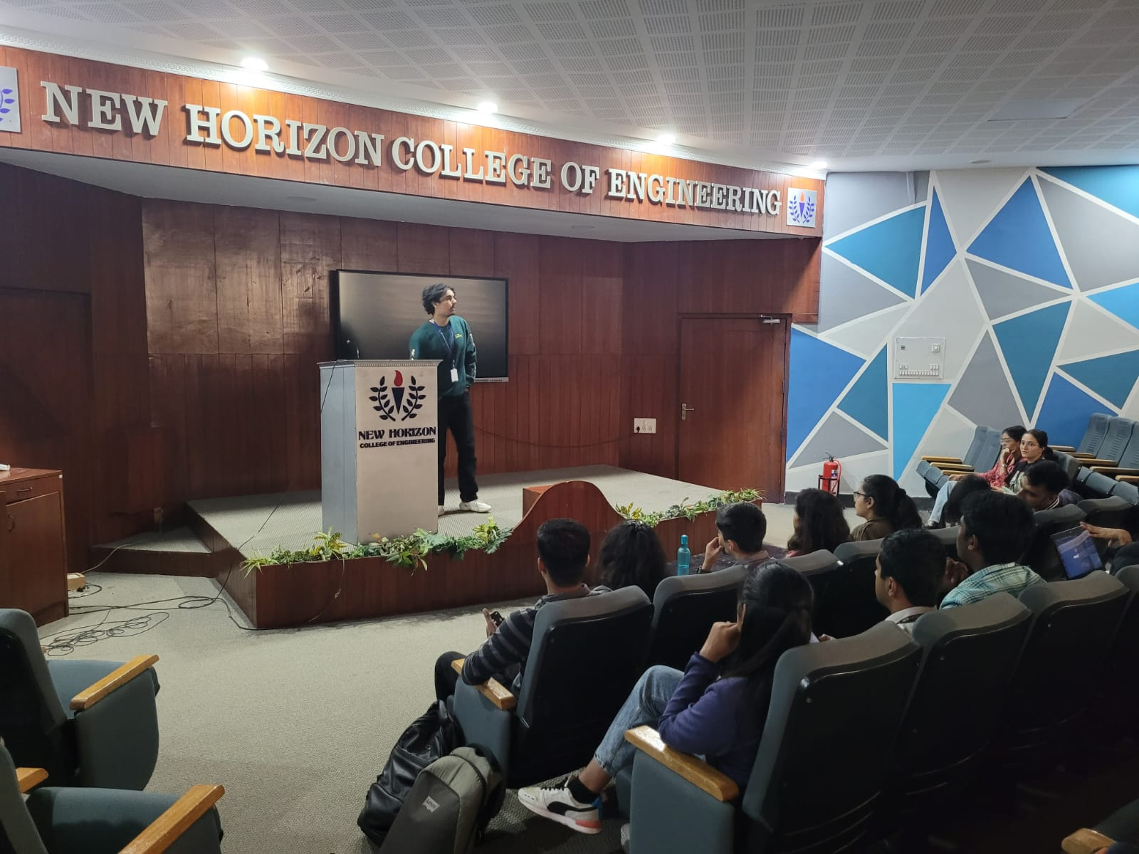

**Summary:**

Participants collaboratively generated inventive solutions. Pitch sessions showcased the creativity, and awards celebrated standout ideas. The event's impact extends beyond as promising projects emerge, demonstrating the Ideathon's lasting influence. The ideation process encouraged out-of-the-box thinking and problem-solving skills.

**Event Poster** :

