**Digital Storage is a Good Bet**

Tom Coughlin, President, Coughlin Associates will be speak at our next IEEE Las Vegas Section meeting, to be held on Wednesday, October 9, 2013 at UNLV’s Science and Engineering Building (SEB). This meeting is co-sponsored by UNLV’s College of Engineering and the IEEE Computer Society of Las Vegas.

Dinner will be served in the SEB lobby from 6-7, and Dr. Coughlin’s presentation will be given right after dinner.

Dinner and the meeting are fee to IEEE members who RSVP. For those who RSVP, there will be a $20 charge at the door for non-members, and a $10 charge for student non-members.

Please RSVP to Julie Longo, IEEE Las Vegas Section Secretary, at [julie.longo@unlv.edu](mailto:julie.longo@unlv.edu) to reserve your seat. Please indicate if you are attending both the dinner and meeting or just the meeting.

------------------------------------------------------------------------------------------------------------

Digital Storage is a vital component in modern electronic devices and applications whether this storage is local or remote. Storage device technology is rapidly evolving and this is shaping important changes in communications and computer architecture to make use of these new storage capabilities. This talk will look at developments and roadmaps for storage device technologies, look at the how this is shaping data communications and show how this will change computer architectures and resulting client and enterprise applications. Some particular examples for developing applications and use of digital storage will be given for the professional media and entertainment industry and might be of particular interest to engineers working on Las Vegas entertainment projects.

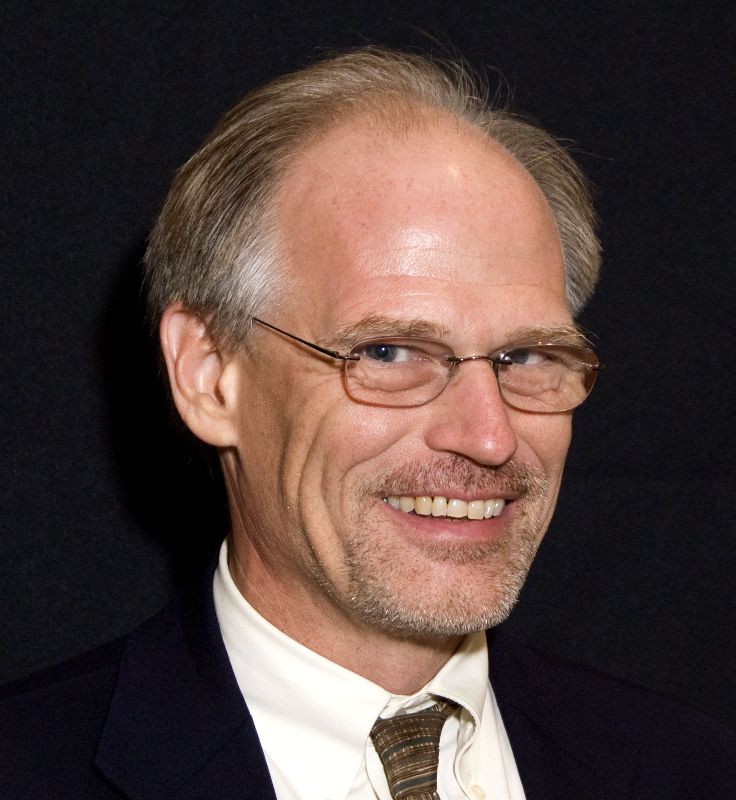Tom Coughlin, President, Coughlin Associates is a widely respected storage analyst and consultant. He has over 30 years in the data storage industry with multiple engineering and management positions at high profile companies.

Dr. Coughlin has many publications and six patents to his credit. Tom is also the author of Digital Storage in Consumer Electronics: The Essential Guide, which was published by Newnes Press. Coughlin Associates provides market and technology analysis (including reports on several digital storage technologies and applications and a newsletter) as well as Data Storage Technical Consulting services. Tom publishes the *Digital Storage Technology Newsletter, the Media and Entertainment Storage Report*, *and the Capital Equipment and Technology for the Hard Disk Drive Industry Report*.

Tom is active with SMPTE, SNIA, the IEEE Magnetics Society, IEEE Consumer Electronics Society, and other professional organizations. He is in charge of Future Directions for the IEEE Consumer Electronics Society, is a member of the IEEE Future Directions Committee as well as Director Elect for IEEE Region 6. Tom is the founder and organizer of the Annual Storage Visions Conference ([www.storagevisions.com](http://www.storagevisions.com)), a partner to the International Consumer Electronics Show, as well as the Creative Storage Conference ([www.creativestorage.org](http://www.creativestorage.org)). He is the general chairman of the annual Flash Memory Summit. He is a Senior member of the IEEE, Leader in the Gerson Lehrman Group Councils of Advisors and a member of the Consultants Network of Silicon Valley (CNSV). For more information on Tom Coughlin and his publications. go to [www.tomcoughlin.com](http://www.tomcoughlin.com/" \t "_parent).