2016 ISGT Instructor Bios

Tutorial Presenters

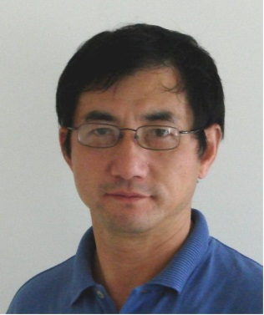 Dr. Yi Hu (IEEE Fellow) is Director - Wide Area Monitoring, Protection and Control, has over 24 years of experience working with electric utilities and vendors. He has developed a number of concepts and methods to improve power system operation, protection and control and consulted for many customers. Dr. Hu has led the Quanta Technology team to win several major WAMPAC projects in the U.S. and Internationally, such as U.S. DOE/NETL NASPInet Specification project, Brazil ONS PMU Certification project. Dr. Hu has been actively involved in IEEE PES Power System Relaying Committee (PSRC) and North America SynchroPhasor Initiative (NASPI) activities. He is an active member of several PSRC working group members. Dr. Hu co-authored the "PMU System Testing and Calibration Guide" for NASPI PSTT.

Dr. Julio Romero Agüero (IEEE Senior Member) is Vice President, Strategy & Business Innovation & Executive Advisor at Quanta Technology. He has over 20 years of experience working with electric utilities and regulatory boards. His areas of expertise are planning, operations, and analysis of power distribution systems, smart grid, and integration of Distributed Energy Resources (DER). Julio is former Commissioner of the National Energy Commission of Honduras, Chair of the IEEE Distribution Subcommittee, Vice Chair of the IEEE Working Group on Distributed Resources Integration, Editor of IEEE Transactions on Smart Grid, Editor of IEEE Transactions on Power Delivery and Member of the Advisory Committee of DistribuTECH. He is the author of over 60 technical papers and presentations, and is a frequent speaker in industry events.

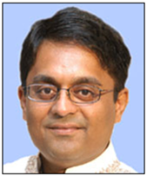 Anant Venkateswaran, M.S, CEM

Mr. Anant Venkateswaran is an industry thought leader, teacher, presenter and has over 20+ years of global experience. Anant has supported strategy, business case, cost-benefit analysis etc., and the development solution architectures, roadmaps and business cases and subsequently technology adoption and solutions delivery phases. Anant has conducted workshops with customers globally, resulting in their business challenges being translated first into innovative concepts and subsequently into intelligent solutions. Having been on both sides of the procurement process, Anant believes in reaching across and partnering with multiple customer stakeholders and developing comprehensive solution strategies and execution roadmaps. Anant currently serves GE’s Grid Solutions business.

Dr. Farid Katiraei (IEEE Senior Member) is Senior Director of Renewable Integration and Microgrids for Quanta Technology. He has more than 14 years of professional experience in the areas of distributed generation interconnection, power electronics and modeling and analysis of system transients and dynamics. In the recent years, Farid has been the technical leads for design, development and testing of several pilot projects for utilities in North America involving renewable technologies, advanced distribution automation, PMUs, energy storage and microgrids. Farid has received his PhD from university of Toronto in 2005. He is a Senior Member of IEEE, chair of the steering committee of the international microgrid symposium, and active participants in several technical working groups and standards development task forces within IEEE, IEC and CIGRE.

Eric A. Udren, Executive Advisor, has 40 years of experience in design and application of protective relaying, control, and communications systems. He developed software for the world’s first computer-based relaying system, and oversaw relaying and control software development for the world's first LAN-based integrated EHV substation protection and control system. He led the design of the first interface of a microprocessor protective relay to an optical current sensor. Mr. Udren is a Fellow of IEEE, Member of the IEEE Power System Relaying Committee (PSRC), Chair of two Standards Working Groups, and Vice Chair of the Relaying Communications Subcommittee. Eric serves on the NERC System Protection and Control Subcommittee, and the NERC Protection System Maintenance Standard Drafting Team. He has written and presented over 60 technical papers.

Doug Houseman
Doug Houseman, VP of Technical Innovation, is working with clients all over North America and Australia on issues related to Smart Grid/Metering/Homes and other related issues. He works with regulators, utilities and vendors to the market to help move the industry to the next generation grid, as well as the next generation of customer relationship.

Doug has extensive experience in the energy and utility industry and has been involved in projects in more than 30 countries. He is routinely invited to speak at international events in the industry and has been widely quoted in a number of international publications. Doug was named part of the World Generation Class of 2007, one of 30 people in the global utility and energy industry so named. He was the lead investigator on one of the largest studies on the future of distribution companies over the last 5 years working with more than 100 utilities and 20 governments.

Doug has a broad background in Utilities and Energy. He worked for Capgemini in the Energy Practice for more than 15 years. During that time he rose to the position of CTO of the 12,000 person practice. During that same time Capgemini grew from less than $10 million dollars in Energy related revenue to more than $2.4 billion. Doug was part of the Global leadership team and worked all over the world in a thought leadership and delivery role. During that time Doug founded the Smart Energy Alliance, lead the Distribution Roadmap 2025, and developed the smart metering and smart grid practices.
Hugo Bashualdo, Specialized engineering and managerial experience within the distribution system. His technical expertise includes distribution planning, distributed generation interconnection impact studies, power losses reduction strategies, reliability improvement studies, and the design, construction and maintenance of distribution systems. He has led various areas within a distribution utility business, including:
Technical Analysis; Design and Construction; Power Losses Control; Distribution Studies; and Planning, Tariff, Control, and IT. He improved the technical and economic performance of each area he managed. Mr. Bashualdo joined Siemens PTI in February 2012, and leads the consulting group in Microgrids and Distribution Planning.

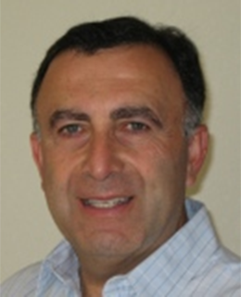 Dr. Ali Ipakchi
Dr. Ali Ipakchi has over 35 years of experience in information technology applications to power systems and electric utility operations. As the Senior Vice President of Smart Grid and Green Power at Open Access Technology International, Inc. (OATI), he is responsible for products and business strategy for the Grid Modernization area. Prior to OATI, Dr. Ipakchi was Vice President of Integration Services at KEMA Consulting, assisting utilities with roadmaps, specifications, and implementation strategies in the Smart Grid area. He has also held various senior management positions at ABB and Alstom, supporting power application development and system delivery to the power industry. His areas of experience include utility and power systems operations, operational IT and automation systems for control centers, trading floors, energy markets and ISOs, as well as, distribution utilities and distributed energy resources. Dr. Ipakchi is co-holder of several US patents on power systems applications and instrument diagnostics. Dr. Ipakchi has been an active member of NEASB Smart Grid task force, NIST SGIP, UCAi, OpenSG and a number of other industry initiatives. He frequently is an invited speaker at industry smart grid events.

