IEEE PES Women in Power’s Boston Chapter hosted an insightful and well-attended panel event, *Women Revolutionizing the Face of Energy*, on Wednesday, June 15th at the EnerNOC Headquarters in Boston’s Seaport District. IEEE PES WiP invited local students and professionals to learn from experienced and empowering women in the energy industry.

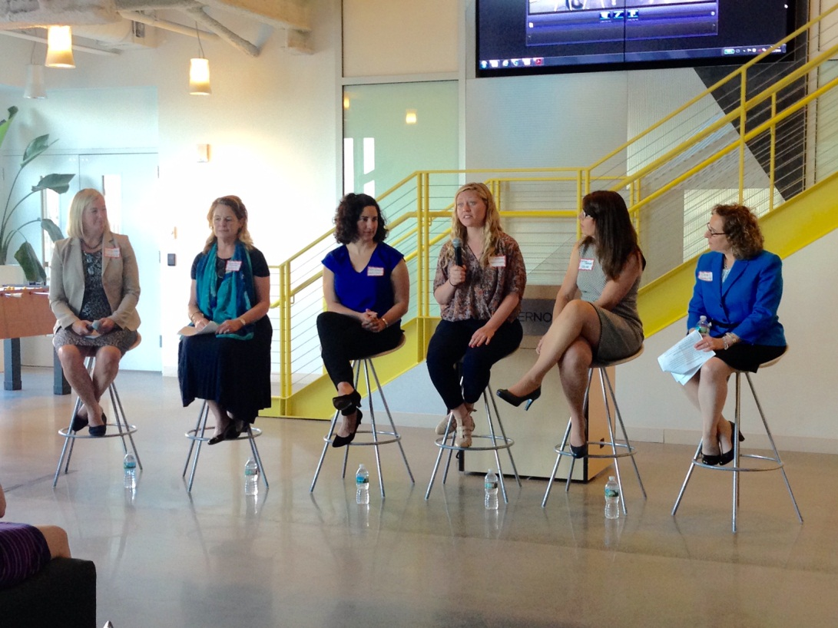

*Left to Right: Moderator Marcy Reed, Panelists Sarah Finnie Robinson, Ayse Coskun,*

*Pia Kristiansen, Carissa Sedlacek, Carol Sedewitz*

Moderator Marcy Reed, President of National Grid MA, inquired her panelists about their career paths, challenges, failures, major milestones, work and life balance, and more. Ayse Coskun, one of the panelists, provided keen insight into the computer engineering industry as one of few women in the developing field of green computing. Ayse commented, “It was a wonderful event, thanks for inviting me. I had a great time meeting women leaders in the energy industry and overall enjoyed meeting so many bright and enthusiastic women pursuing a variety of career paths. I feel that such events that enable sharing of experiences and networking are key to increasing the number and impact of women in power and energy, key growing fields for the future.”

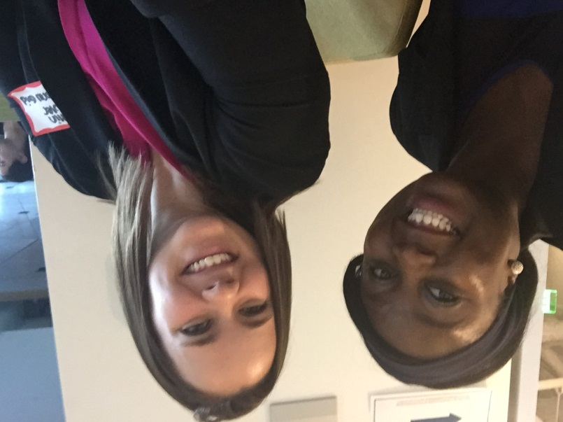

*WiP Boston Planning Committee Members Amsa Mangga and Caitlin Fowler*

Caitlin Fowler, WiP Planning Committee member, noted, “I really enjoyed hearing from six panelists who have diverse backgrounds and careers within the energy industry. Each speaker had a unique career path and different words of wisdom. It was both interesting and encouraging to hear from these women in leadership positions and the challenges they have overcome.”

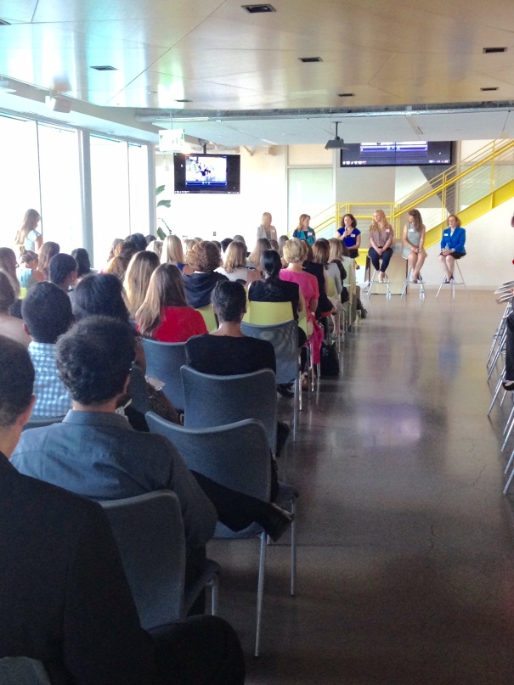“It was a nice event. It was encouraging to see women in leading roles in a male dominated industry and hear their different experiences,” explains Tomi Fadipe, Lead Engineer at Eversource. Souresh Mukherjee, Engineer at National Grid, described his experience with the event: "It was a very well organized program. All the panelists, being power industry leaders, were quite articulate in sharing interesting stories and anecdotes about their careers. Each one of them had their unique take on how to overcome roadblocks and move ahead in your career. It was inspiring to hear how they took on challenging responsibilities and never shied away from taking up difficult tasks. Also, the venue was amazing!"

The night closed with thriving networking overlooking the water at the Seaport. Thanks to our special moderator and panelists and to all guests who attended and made the event such a fun success! Please reach out to [wip.ieeeboston@gmail.com](mailto:wip.ieeeboston@gmail.com) with questions, and keep an eye out for upcoming events in your area!

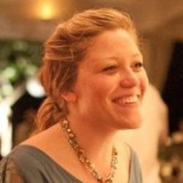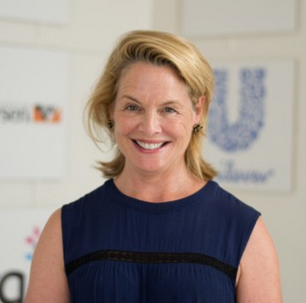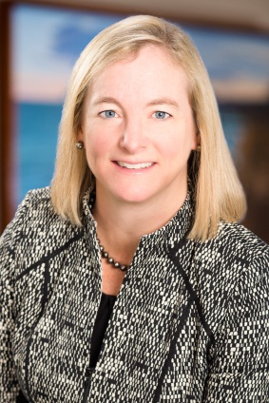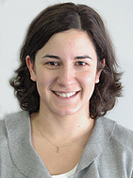

*Ayse Coskun*

*BU ECE Professor*

*Marcy L. Reed*

*President of National Grid-MA*

*Sarah Finnie Robinson*

*Founding Partner, WeSpire*

*Pia Kristiansen*

*ENERNOC Utility Product Manager*

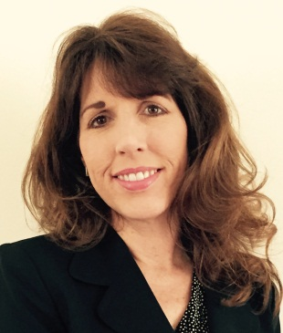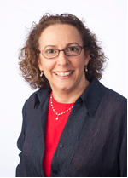

*Carissa Sedlacek*

*Resource Adequacy, ISO-NE*

*Carol Sedewitz*

*VP Asset Management, National Grid*